Wege in der Begabungsförderung im Fach Englisch – Handouts

Inhaltsverzeichnis
1. Drehtürmodell – Handouts 2
2. Lernverträge – Handouts 6
3. Atelierbetrieb – Handouts 9
4. Portfolios – Handouts 12
5. Peer Teaching – Handouts 20
6. Zwei-Phasen-Unterricht – Handouts 23
7. Blooms Lernzieltaxonomie – Handouts 25
8. Multiple Intelligenzen – Handouts 30
9. Flipped Classroom – Handouts 37
10. Flexible Gruppierung – Handouts 40
11. Englische Lerninseln – Handouts 44
12. Stationenlernen – Handouts 51
13. Offene Aufgaben – Handouts 55
14. Forschendes Lernen – Handouts 61
15. Begabungsfördernde Leistungsbeurteilung – Handouts 63
16. Formatives Assessment – Handouts 66
17. Förderorientierte Leistungsrückmeldung durch Peer-Feedback – Handouts 70

- Drehtürmodell – Handouts

AGREEMENT
Kopiervorlage DTM 1A
on the Use of the Revolving Door Model
during English lessons

between Max Mustermann class … (student)
and Jane Doe (English teacher)

Due to excellent and above-average English skills
the student is allowed to leave the English classes on the following conditions:
- During the first term, from ___ September 2021_ to ___ January 2022_, the student uses every English lesson on ___ and ___ to work on an individual project (while the class is involved with the teacher).
- The student agrees to use this time responsibly.
- The student agrees to work on and complete the following project: ___
- This project includes the detailed planning of relevant steps (aims, stages, possible obstacles, methods, cooperation with the teacher etc.).
- The final product(s) of the project is/are:
- a 10-page dossier handed in to the teacher
- a peer teaching unit (including a handout) on ___
- a 15-minute presentation in English to ___ during a/an ___ lesson at the end of the first term
- The student agrees to
- autonomously study the contents of the regular lessons she/he misses.
- hand in homework on time.
- attend regular English lessons when one day's notice is given by the teacher.
- fill in a “Student Self-Evaluation Form” and to hand it in after completing the project.
- Evaluation and grading: The fulfilment of the project in outstanding quality is a precondition for the mark “Sehr gut“ in the compulsory subject English.
- This contract can be terminated by either party without any consequences within six weeks, i.e. up to and including __ ___ 202__.
The above-mentioned terms are agreed on by teacher and student.
________________(date)

_________________ __________________ ____________________
Student’s signature Teacher’s signature Parents’ signature

AGREEMENT
Kopiervorlage DTM 1B
on the Use of the Revolving Door Model
during English lessons

between ___________________ (student), class _______
and _____________________ (English teacher)

Due to ____________________________________________________________________
the student is allowed to leave the English classes on the following conditions:
- Period of time to work on an individual project (while the class is involved with the teacher):
Date (from – to): _______________________ Lessons: __________________________
- The student agrees to use this time responsibly.
- The student agrees to work on and complete the following project:
________________________________________________________________________
- This project includes:
________________________________________________________________________
- The final product(s) of the project is/are:
________________________________________________________________________
________________________________________________________________________
________________________________________________________________________
- The student agrees to
- autonomously study the contents of the regular lessons she/he misses.
- hand in homework on time.
- attend regular English lessons when one day's notice is given by the teacher.
- fill in a “Student Self-Evaluation Form” and to hand it in after completing the project.
- Evaluation and grading:
________________________________________________________________________
- This contract can be terminated by either party without any consequences within ____
weeks, i.e. up to and including __________________ (date).
The above-mentioned terms are agreed on by teacher and student.
________________(date)

_________________ __________________ ____________________
Student’s signature Teacher’s signature Parents’ signature
Kopiervorlage DTM 2

STUDENT SELF-EVALUATION FORM
on the Use of the Revolving Door Model
during English lessons

Answer the following questions to reflect on your individual project.
Justify your answers.

EVALUATION OF THE AGREEMENT ON THE USE OF THE REVOLVING DOOR MODEL:

After having completed your project, how did you like the chance of using the Revolving Door Model in English classes?

In how far were your expectations about the Revolving Door Model fulfilled?

Would you opt for this model again in the future? Why? Why not?

Was it still possible for you to follow the regular English classes or did you feel overtaxed?

EVALUATION OF THE INDIVIDUAL PROJECT as to the learning process:

How did you experience the process from beginning to end?

Were there any problems you had to deal with?

What resources helped you most?

Is there something you would change next time?

EVALUATION OF THE INDIVIDUAL PROJECT as to the final product/s:

What do you think about your final product? What are you proud of, what could be improved?

From your teacher’s point of view: How would your teacher assess your final product? How would they grade it?

From your classmates’ point of view: What would they think about your product?

- Lernverträge – Handouts

Kopiervorlage LV 1

(Possible) Elements of a

LEARNING CONTRACT

1. Teaching objectives/competences:
Teaching and learning objectives/competences as defined in the curriculum:
prioritising is done with the students
Further specific focuses

2. Contents and topics:
Outline of the year’s core topics (agreed on with the students)
Specialised topics:
  - for the entire class
  - for individual students

3. Assessment and grading:
Criteria for assessment: to be negotiated with the students
General assessment for the class
Individual assessments

4. Form of organization, methods and learning techniques:
Organization of lessons and working techniques:
  - Social structure: individual work, pair work, group work
  - Input phases and phases of individual work
  - Methods and learning techniques
Material:
- Coursebooks, internet
- Additional material

5. Social interaction:
Setting to achieve the teaching and learning objectives:
- Teacher’s expectations of students
- Students’ expectations of teacher
- Students’ expectations of their peers

INDIVIDUAL LEARNING CONTRACT
Kopiervorlage LV 2

between _____________________, class _____
(student)

and _________________
(English teacher)
The student works on an individual project on the following conditions:
- Period of time:
Date (from – to): ___________________ Lessons: __________________________
- The student agrees to use this time responsibly.
- The student agrees to work on and complete the following project:
________________________________________________________________________
- This project includes:
________________________________________________________________________
________________________________________________________________________
- The final product(s) of the project is/are:
________________________________________________________________________
________________________________________________________________________
________________________________________________________________________
- Evaluation and grade:
________________________________________________________________________
________________________________________________________________________
- This contract can be terminated by either party without any consequences within _______ weeks, i.e. up to and including __________________________ (date).

The above-mentioned terms are agreed on by teacher and student.
________________(date)

____________________ ____________________ ____________________
Student’s signature Teacher’s signature Parents’ signature

- Atelierbetrieb – Handouts

Anmeldung zu den Ateliers
Kopiervorlage AB 1

Atelier 1 – English Workshop: ______________________________ (title)
Short description: _______________________________________________________________________
______________________________________________________________________________________

Termine – Teilnehmerinnen und Teilnehmer
Atelier 1 – English Workshop: Termin 1: ____ - ___ _ Raum:___ __
NAME – KLASSE | NAME – KLASSE
1. | 6.
2. | 7.
3. | 8.
4. | 9.
5. | 10.

Atelier 1 – English Workshop: Termin 2: ____ - ___ _ Raum:___ __
NAME – KLASSE | NAME – KLASSE
1. | 6.
2. | 7.
3. | 8.
4. | 9.
5. | 10.

Atelier 2 – Schreibwerkstatt: ______________________________ (Titel)
Kurzbeschreibung: _______________________________________________________________________
______________________________________________________________________________________

Termine – Teilnehmerinnen und Teilnehmer
Atelier 2 – Schreibwerkstatt: Termin 1: ____ - ___ _ Raum:___ __
NAME – KLASSE | NAME – KLASSE
1. | 6.
2. | 7.
3. | 8.
4. | 9.
5. | 10.

Atelier 2 – Schreibwerkstatt: Termin 2: ____ - ___ _ Raum:___ __
NAME – KLASSE | NAME – KLASSE
1. | 6.
2. | 7.
3. | 8.
4. | 9.
5. | 10.

Kopiervorlage AB 2

Laufzettel – Ateliertag(E)

NAME: ____________________________ Klasse: ________ Datum: _______________

 | ATELIER | RAUM | TEILNAHMEBESTÄTIGUNG
1 | English Workshop | 8AR
2 | Schreibwerkstatt | 6BR
3
4
5
6
7
8
9

- Portfolios – Handouts

Kopiervorlage PF 1

MY ENGLISH PORTFOLIO
Guidelines

- This year we are going to work with a portfolio in our English class.
- You will decide the layout of your portfolio: You can keep your portfolio in a neat notebook, an extra folder or in an online file.
Important: Create an appealing collection of your work that you can be proud of.
- Here is the basic information for the organisation, contents, and feedback:

Categories | Examples
Structure and organisation | Your portfolio has to include  - a cover page  - a table of contents  - an introduction to the reader  - an explanation for the selection of the products presented
Mandatory documents | - work assignments defined for the portfolio, e.g., Learning Diary, Reading Diary, Working with Words, Feedback  - handouts for presentations  - feedback and self-reflection (see below)
Additional and voluntary documents | - any voluntary text entries to your Learning Diary  - additional books/stories for your Reading Diary  - vocabulary for the “Favourite English Words and Phrases/New for Me” section  - any additional voluntary research on topics in class or of personal interest
Self-reflection and feedback | - justify the choice of the documents for the portfolio  - assess your personal achievement  - give feedback on the portfolio work in general  - supply feedback to your teacher on the tasks of the portfolio in particular

Kopiervorlage PF 2

MY LEARNING DIARY

Keep a learning diary for at least two months to reflect on your personal learning and make regular entries (in full sentences).
Be creative when it comes to the design of your learning diary.

Your diary entries must include the following aspects:
Date
Topic/s of the lesson
What was interesting? Why?
What did you enjoy most? Why?
What was a/the less interesting aspect? Why?
Was there something that surprised you? Why?
What did you learn that you didn’t know before?
What would you like to learn more of?

READING DIARY
Kopiervorlage PF 3
Tips for keeping a reading diary

Whenever you read a story/book in English try out the following ideas:
- Reading your story/book:
- First of all, enjoy reading your story/book!
- While reading try to imagine the scenes and to see life through the main character’s eyes.
- Comment/response writing:
- After reading, think about it for a while, then write a personal reaction/response.
- Decide for how long you want to write and stick to it for 5, 10 or 15 minutes.
- Consider three to five of these questions:
- Do/did you enjoy reading this story/book? Why? Why not?
- Are the characters interesting/amusing/fascinating/well-developed/thought-provoking?
- Who is your favourite character? What makes him/her special?
- Is there a character you don’t like at all? Why?
- If you were one of the characters which one would you like to be? Explain why.
- Which are your favourite scenes? Say why.
- What events or characters do you (not) understand?
- What would you tell the author if you met him/her?
- Helpful phrases:
These sentences may help you to express your ideas in English. You can of course use your own wording as well.

Helpful phrases to express …
… how we can talk about a story/ a text/a book. | I think the story/text/book is …  …interesting/nice/gripping/good to read/a great read/ fantastic, …  … terrible/shocking, …  … because …
… what you like/do not like about the story/text/book.  Why (not)? | I (don’t) like the scene …, because …
… which scene/situation/incident is really great/fabulous/interesting.  Why (not)? | For me, … is just great/super/brilliant/terrific/horrible …, because …
… which person/character in the story/book you like (do not like). Why (not)? | My favourite character in the book is …, because …
Kopiervorlage PF 4

FAVOURITE ENGLISH WORDS AND PHRASES/NEW FOR ME

1. Preparation/assignment:
- Choose any English words or phrases that sound new/interesting/fancy to you and bring them to class.
- Make sure you can tell where you found the words and why you picked them.
- Use the graphic organizer:
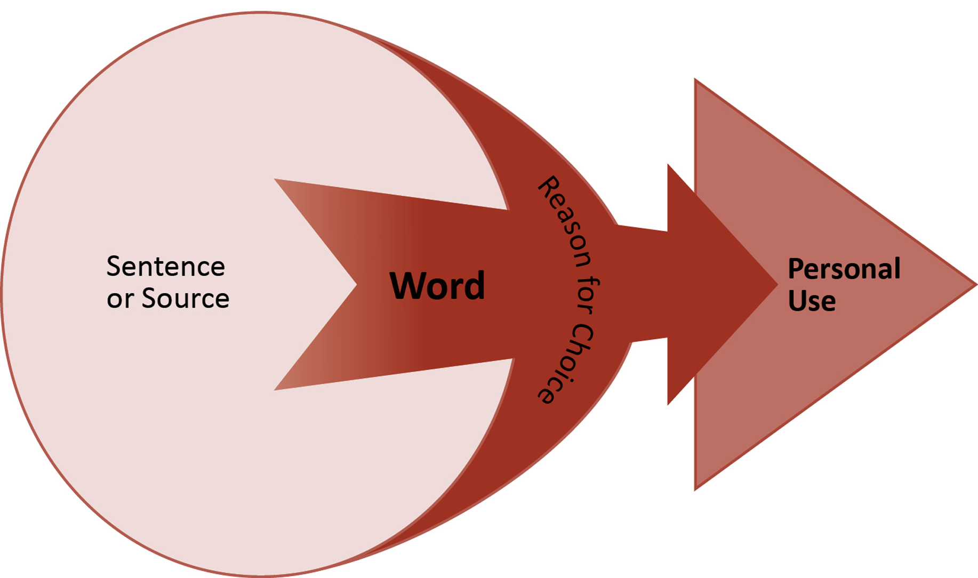

2. Work in class:
- In our weekly language swapping lesson you will present your words.
- Ask three other people about their favourite English words and note down their explanations.

3. Personal use of words and phrases:
- Use a selection of your phrases in a creative text of your own:
- slogan for a promotion campaign
- advertisement
- poem
- acrostic
- song lyrics

Kopiervorlage PF 5A

WORKING WITH WORDS
Guidelines

1. Preparation/Homework:
- Pick any ten to fifteen words from the unit vocabulary that you consider important.
- With each of the words …
- try to find a (different) task to be used in class and
- signal the level of difficulty (*/**/***)
- Here is a list of different tasks/activities you can choose from:
- explain the word/write a definition
- use the word in a mini-dialogue
- find the opposite (antonym)
- find another word with the same meaning (synonym)
- draw the word
- create a word field by means of a mind map
- find the noun/adjective/verb for it
- create a gapped sentence where the word fits
- create a taboo card for the word
- make an acrostic
- find the word in a text on the internet
- create a snapdragon with words and definitions
- find a question so that the word would be the answer
- create a vocabulary recapping task for the class
- Extra work: ++
- Design your own templates for the different tasks.

2. Work in class or in settings of autonomous learning:
- Challenge each other in PW/GW/team competitions.
- Take the role of the teacher and create an activity to practise the vocabulary, e.g., “hot seat” your peers.
- Establish rules for the different levels of difficulty (*/**/***).
- Use the words in a text of your own and underline or highlight the words you have used.

WORKING WITH WORDS
Kopiervorlage PF 5B
Template

- Choose ten important words from a topic we discussed in class.
- Below you will find ten different tasks.
- You decide which task you do with which word (a different task for every word).
- Write the word you have chosen in the line provided.
- You can fill in the grid below or use the grid as a template to design your own sheet.

Define it: | Use it in a sentence:
Find (an) antonym/antonyms: | Find (a) synonym/synonyms:
Create a word field by means of a mind map:
Draw it: | Rhyme time:
Make an acrostic (a poem in which the first letter of each line spells out a word or phrase): | Word formation: find appropriate nouns/verbs/adjectives/adverbs, …:
Look for a newspaper article in which the word is used and quote the sentence (and your source):

Kopiervorlage PF 6

FEEDBACK ON THE TASKS OF THE PORTFOLIO
Guidelines

- By now you have worked on a number of different tasks on topics we have discussed in the English lessons and possibly added texts and products on a voluntary basis.
- So that I get valuable feedback please reconsider your personal progress and answer the questions below.
- You may answer each of the questions in a few sentences or you write me an email starting with … “Dear Mr/Mrs …” in which you refer to the aspects below.

Questions/aspects to be considered:

1. Feedback on the portfolio work in general:
- Goal of the English portfolio:
A goal of the portfolio work is that you deal with your own learning and with topics
discussed in the English lessons in more detail.
- In how far do you think you have reached this goal?
- Is it possible to reach this goal by working on the tasks of the English portfolio?

- Different tasks of the English portfolio:
- Did you like the different tasks of the English portfolio? Why? Why not?
- Which tasks did you especially appreciate? Which tasks did you find less interesting?

2. Feedback to your teacher in particular:
- Tasks:
- Which task/s would you especially like to discuss with your teacher? Why?
- If you were the teacher of this class, what would you do to make the tasks more useful?
- Which tasks would you include/leave out in the portfolio?

- Grading:
- What do you think about the possibility of improving your grade by creating an English portfolio? Is it a satisfying alternative?
- Which (additional) possibilities to improve your grade in English would you wish to have?

- Peer Teaching – Handouts

Kopiervorlage PT 1A

Guidelines for

PEER TEACHING
Elementary to intermediate level

Definition:

Peer teaching means that you – the students – take on the teacher’s role and teach your classmates (= your peers) in differently long sections.

You must prepare the task so that you know your subject well and will be able to teach it to your peers.
Your teacher may give you material or you may have free choice of subject.
You can peer-teach on your own or with a partner.
Checklist for your preparation:

For your preparation it is important that you know about:
- Task: what exactly you will have to do.
- Length of your teaching: how long you will have to teach.
- Organisation of your teaching:
3. 1. Material:
Have enough/questions/sentences to practise with the class.
3. 2. Basics:
Be well-prepared and know what you will be doing so that you can speak freely without looking at your notes too often.
Prepare possible solutions on a PPT or on a document that you can show.
3. 3. Social interaction: individual work (IW), pair work (PW), group work (GW)
Tips for your peer teaching:

- Make sure the class is quiet before you start teaching.
- Speak slowly, clearly, and loud enough for everyone to hear and understand you.
- Give all your peers a chance to say something.
- Make a call for order if necessary, so that YOU lead the class.
- Make sure that everyone has understood the solution/answers.
- Give feedback to your peers’ answers.

Kopiervorlage PT 1B
Guidelines for

PEER TEACHING
Upper intermediate to advanced level
Definition:
Peer teaching is a teaching and learning strategy where you – the students – take on a teaching role and teach your peers in variably long sequences and on different topics.

You must prepare the topic/text well so that you will be able to teach the issue to your peers.
You may be given material to prepare from your teacher or have free choice of subject.
Peer teaching can be done individually or in pairs.
Checklist for your preparation:
Consider the following aspects for your preparation of the sequence/lesson:
- Topic/text and length of teaching sequence: to be arranged with your teacher
- Structure/organisation and design according to the length of the sequences:
  - Introduction: picture, quote, brainstorming, song, short video clip, visuals etc.
  - Lead-on sequences: material to be used and how
  - Wind-up: secure the take-away message: note taking, recapping
  - Social interaction: individual work (IW), pair work (PW), group work (GW)
  - Feedback: secure at least 5 – 10 minutes for feedback by peers and teacher at the end of your teaching session
- Aspects to be considered in addition to your text:
  - Teaching objective: define what your peers shall know by the end of the lesson.
  - Vocabulary: prepare vocab to be dealt with differently from G-E translations.
  - Questions on and beyond the text: comprehension and discussion questions
  - Activities: quizzes, different tasks
- Sources: Quote the sources of all the material you are going to use in your peer-teaching.
- Handout: Prepare a handout according to the structure of your lesson and hand it in to your teacher a week ahead of your peer-teaching session.
- Edit the handout accordingly after the discussion with your teacher.
- Upload the material of your peer teaching session on the file installed by your teacher.

- Zwei-Phasen-Unterricht – Handouts

Kopiervorlage PU 1

Feedback: Zwei-Phasen-Unterricht/Two-Phase-Lesson

Group chosen: __________________________________________________________
Reason/Motivation: __________________________________________________________
__________________________________________________________
__________________________________________________________
__________________________________________________________
__________________________________________________________
__________________________________________________________
__________________________________________________________
Experience gained: __________________________________________________________
__________________________________________________________
__________________________________________________________
__________________________________________________________
__________________________________________________________
__________________________________________________________
__________________________________________________________

- Blooms Lernzieltaxonomie – Handouts

1. Bloom’s Taxonomy Table
Sample activities | - Answering questions on a text  - Completing ap-filling/multiple-choice worksheets  - Underlining words (e.g., adjectives) in a text  - Listing things that have to do with the topic  - Labelling different parts of a diagram  - Arranging items in order  - Writing definitions for keywords/matching words with definitions | - Reading comprehension questions  - Restating information in your own words  - Explaining answers to questions  - Identifying/underlining key points  - Writing sub-headings  - Writing a summary  - Explaining a new content/what you already know to a peer  - Predicting grammatical patterns  - Identifying the reason behind an individual′s behaviour in a story  - Sorting ideas into categories/ mind mapping  - Identifying mistakes and correcting them | - Applying knowledge to a real-life situation  - Using knowledge to explain something  - Using knowledge to solve a problem  - Role-playing  - Preparing and giving a presentation  - Writing a story about a minor character/from another point of view
Appropriate verbs | arrange, choose, copy, define, describe, draw, identify, label, list, locate, memorise, mime, name, order, outline, point, pick, quote, recall, recite, record, repeat, reproduce, restate, retain, select, state, underline, write (down) | characterise, classify, compare, complete, confirm, convert, define, describe, discuss, establish, estimate, exemplify, explain, express, give examples, identify, illustrate, indicate, interpret, infer, match, paraphrase, predict, recognise, relate, report, rewrite, sort, specify, summarize, translate | apply, build, calculate, choose, classify, communicate, construct, contrast, demonstrate, develop, diagnose, dramatize, edit, employ, estimate, execute, identify, implement, illustrate, model, modify, perform, practice, produce, relate, report, role-play, sketch, solve, suggest, use
Description | Remembering relevant information (terms, facts, procedures, criteria, symbols) | Being able to explain an issue in one′s own words, constructing meaning | Transferring,  using something in another context, applying knowledge
Cognitive level | Knowledge | Comprehension | Application
Kopiervorlage BLT 1A
Kopiervorlage BLT 1B
- Comparing and contrasting information  - Naming similarities and differences  - Breaking down new information and explaining how something works  - Finding and analysing difference  - Sequencing a story  - Exploring the reason for certain behaviour  - Interpreting a situation, text, or event  - Developing criteria for a good/bad example of a text | - Finding a solution to a problem  - Proposing counter arguments  - Creative writing (diary entries, stories, poems,  comics …)  - Creating an advertisement  - Creating a poster  - Creating a role play  - Discussing alternative endings to a story  - Writing a letter to the editor | - Writing about strengths and weaknesses/ pros and cons  - Ranking items according to given criteria  - Writing a report  - Pitching a new (business) idea  - Debating a controversial issue  - Justifying decisions  - Discussing opinions (e.g., of a book or film)  - Writing a recommendation  - Self- and peer-assessment
analyse, appraise, attribute, categorize, change, combine, compare, contrast, debate, diagram, differentiate, discriminate, examine, experiment, explore, figure, find, investigate, modify, organise, question, research, select, solve, survey, sort, test | combine, compile, compose, construct, create, design, develop, devise, formulate, generate, hypothesise, illustrate, integrate, invent, manage, merge, modify, organise, plan, prepare, produce, propose, revise, unite | appraise, argue, assess, check, conclude, consider, criticize, critique, debate, defend, estimate, evaluate, examine, grade, inspect, judge, justify, predict, prioritise, qualify, question, rank, rate, recommend, review, support (your opinion), value, verify
Determining criteria, determining errors, pointing out special features, breaking material into constituent parts | Generalising, putting elements together to form a coherent whole, finding other ways to solve problems, designing plans, creative thinking | Weighing up and selecting alternatives, assessing a situation or making judgements on the basis of criteria
Analysis | Synthesis | Evaluation

Knowledge | In your learning journal/reading diary …  - write what the book is about,  - make a vocabulary list of important words,  - point out what you liked/disliked,  - make a list of the “top three” most important parts of the book.
Comprehension | - add why you like/dislike some parts/characters,  - explain how the book made you feel,  - make a collage (see Explanation of tasks) or poster about the book,  - find “Telling Passages” (see Explanation of tasks).
Application | - If you met the main character in the street,  - what would you talk about?  - what interview questions would you ask him as a reporter?  - Imagine you are one of the characters in the book and write a diary entry about two days in your life.
Analysis | - Compare two or more characters of the book in a “Venn Diagram” (see Explanation of tasks).  - Select a character in the book and compare him/her to yourself: What would I do/have done? (see Explanation of tasks)  - Create a “Story Pyramid” (see Explanation of tasks).
Synthesis | - Create/develop a board game about the book: find a name for it, work out question/answer cards in different levels of difficulty as well as rules for the game.  - Plan an advertising campaign to promote the sale of the book (see Explanation of tasks).
Evaluation | - Invitation for dinner: argue/assess which of the characters in the book you would like to have dinner with? Explain why.  - Review the book in a letter to the author or in a blog post and explain what is important for you that you would like to find in another book.  - Recommend/assess/review the/a book that’s “Good enough to eat” by means of a “Recipe Card” (see Explanation of tasks).
Kopiervorlage BLT 2A

BLOOM’S TAXONOMY AS APPLIED TO STORIES AND NOVELS

EXPLANATION OF TASKS
Kopiervorlage BLT 2B

Collage:
- Make a collage that represents major characters and events in the book you’ve read.
- Use pictures and words cut from magazines or the internet in your collage.
- Add quotes from the book and your own comments.
Telling Passages:
- Choose three passages from your book that you find interesting and telling.
- Explain what these passages tell us about the character(s) and/or the conflict in the book.
- Practise reading the passages and make sure you can speak about them.
Venn Diagram
Character 1
Character 2

Differences:
unique traits or
characteristics

Similarities:
shared traits or
characteristics

Differences:
unique traits or
characteristics

What would I do/have done?
- Choose one of the (main) characters in the book you have just read. Think of their actions, decisions and opinions.
- What is your point of view? Do you agree/disagree with them?
- Explain what you would do/have done differently. Write how this would influence/would have influenced the story:
If I were …. I would ….
If I had (not) been …, I would/wouldn’t have ….
If he/she had …,
Character’s name:

Actions/decisions:
My point of view:

What I would do/have done:

Story Pyramids:
Kopiervorlage BLT 2C
- Write the name of the (main) character in the first line.
- Find two adjectives to describe the (main) character.
- Catch the setting in a three-word phrase or sentence.
- Explain the goal (intention) of the (main) character in a
four-word sentence.
- Create a five-word sentence to show what nearly stopped
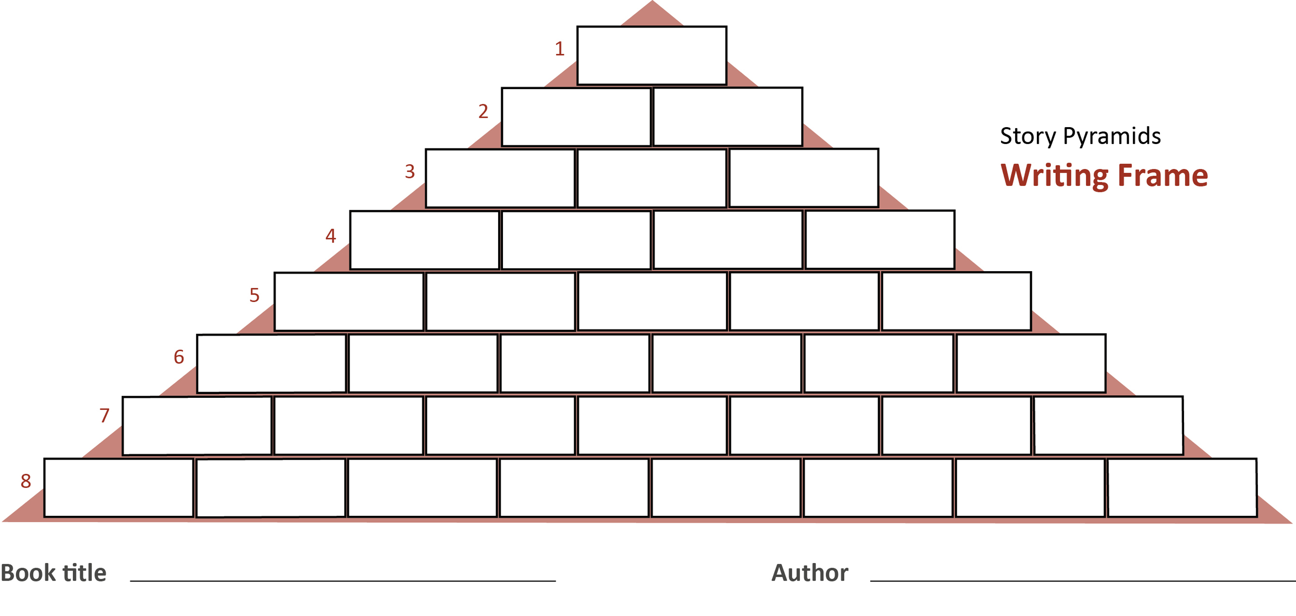
the (main) character from getting to his/her goal.
- Define how the (main) character got what he/she
wanted in a six-word sentence.
- Produce a seven-word sentence that
presents the best part of the story.
- Form an eight-word sentence
explaining why you would/
would not recommend
the read.

Advertising Campaign:
In order to promote the sale of the book you have read you design
a poster or
a magazine ad or
a radio/TV commercial

Recipe Card: “Good enough to eat” – a culinary book recommendation:
Include the following recipe ingredients in your recommendation/assessment/review:
plot – character(s) – setting – mood – theme
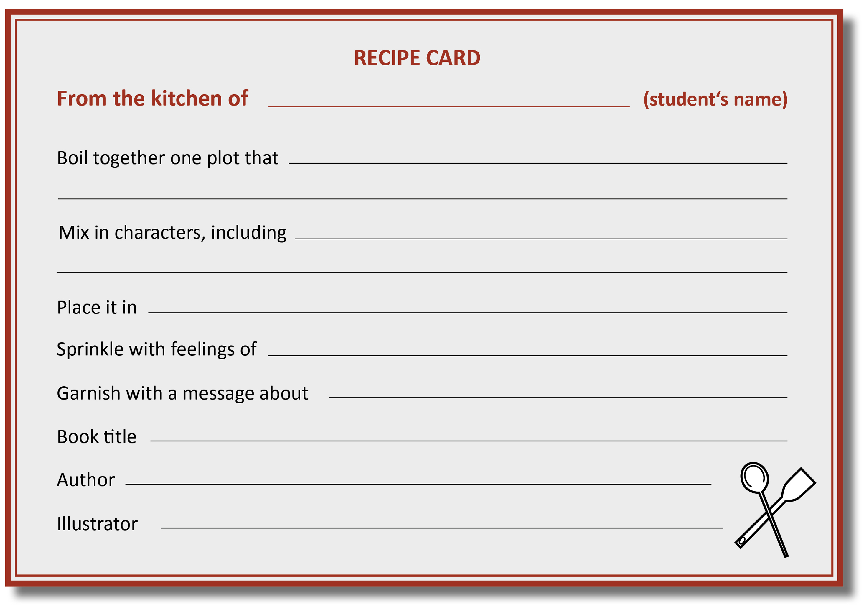

- Multiple Intelligenzen – Handouts

Kopiervorlage MI 1

1. MI-Aufgaben im Englischunterricht
Körperlich-kinästhetischer Schwerpunkt  Miming stories: Geschichten (oder Szenen) werden pantomimisch dargestellt.  Role plays: Die Lernenden machen spontan ein Rollenspiel (Improvisation) oder sie bekommen eine Vorlage und studieren ein play ein.  Barn dances, square dances usw.: Tänze sind Teil der Kulturkunde und fördern die körperlich-kinästhetische ebenso wie die räumliche Intelligenz.  Write on your partner’s back: Eine Schülerin/ein Schüler schreibt mit dem Finger auf dem Rücken einer Mitschülerin/eines Mitschülers ein Wort, das diese/r erraten muss, dann muss eine weitere Aufgabe gelöst werden, z.B. Plural bilden, past participle nennen, Antonym finden, Wort zu Kollokation erweitern usw. | Logisch-mathematischer Schwerpunkt  What would happen if …: What would happen if someone … (did…) something?  Jigsaw puzzles: Diverse Puzzles, dominoes und triminoes können auch von den Lernenden selbst hergestellt werden (siehe Lerninsel).  Graphs and tables: Die Lernenden erstellen selbst Grafiken und Tabellen (zu diversen Themen oder selbst durchgeführten Umfragen) oder versprachlichen vorgegebene Grafiken und Tabellen.  Timelines: Die Lernenden stellen bestimmte Ereignisse (z.B. Biografien, Tagesablauf, historische Ereignisse, wirtschaftliche Entwicklungen, Ereignisse in einem Roman usw.) als timeline dar. | Naturalistischer Schwerpunkt  Nature diaries: Die Lernenden verfassen Tagebücher zu Themen, die mit Natur und Umwelt zu tun haben, z.B. A spring journal, Last week’s weather, My personal energy saving measures.  Nature diagrams: Informationen über bestimmte Tiere (wie Lebensalter, Schlafgewohnheiten usw.) oder Pflanzen werden gesammelt, verglichen und in Diagrammen dargestellt.  Nature research: Die Lernenden recherchieren Fakten und Studien zu einem Thema mit naturalistischem Schwerpunkt und erstellen eine Präsentation, eine Broschüre oder einen Podcast.
Sprachlicher Schwerpunkt  Word detective: In einem Text werden unsinnige Wörter eingefügt, die die Lernenden entdecken müssen („Editing“).  Creating a letter poster (Anfangsunterricht): Die Lernenden sammeln so viele Wörter wie möglich, die mit demselben Anfangsbuchstaben beginnen, und gestalten dazu ein Poster. Eine kreative Gestaltung der Wörter ist gewünscht. Als Alternative kann ein Thema vorgegeben werden (z.B. weather words).  One-minute speech: Die/der Lernende spricht eine Minute lang spontan über ein vorgegebenes Thema.  Story computer: Die Klasse wird in drei Gruppen eingeteilt. Zunächst schneidet jede Gruppe Wörter und Bilder aus englischsprachigen Zeitungen, Zeitschriften usw. aus und gibt diese an die nächste Gruppe weiter. Diese versucht nun, die Wörter und Bilder möglichst sinnvoll zu reihen und die Wörter/Bilder werden so aufgeklebt. Diese Unterlage wird an die nächste Gruppe weitergegeben, die die entstandene Geschichte dann präsentiert. | Multiple Intelligenzen-Aufgaben  im Englischunterricht | Visuell-räumlicher Schwerpunkt  Picture stories: Die Lernenden schreiben Bildergeschichten (diese können von den Lernenden auch selbst gezeichnet werden).  Creating posters/collages: Lernende erstellen Plakate, die Text und Bild kombinieren, oder gestalten eine Collage zu einem Thema (z.B. health).  Picture puzzles: Lernende suchen in Bildern Gemeinsamkeiten und Unterschiede oder müssen ein Objekt in einem Wimmelbild finden. Aufgaben wie diese können als Wettbewerbe konzipiert werden.
Intrapersonaler Schwerpunkt  Barometer of mood: Zu Beginn der Stunde können die Lernenden zur Selbstmotivierung die eigene Verfassung über ein Stimmungsbarometer wiedergeben.  Blitzlicht: Am Ende der Stunde reflektieren die Lernenden kurz über ihre Eindrücke und Gefühle.  Self-reflection: Während des Unterrichts werden Impulse zur Selbstreflexion des eigenen Lernens gegeben (siehe auch Lernverträge, Atelierbetrieb, Portfolio, Stationenlernen, Offene Aufgaben, Formatives Assessment).  Diaries/logs: Ein Lerntagebuch/Lernprotokoll hilft Lernenden, Ihr eigenes Lernen aufzuzeichnen, zu planen, zu strukturieren, zu reflektieren und auch nachzuweisen (siehe Portfolio). | Interpersonaler Schwerpunkt  Questionnaires: Die Lernenden machen Umfragen in der Klasse oder Schule zu beliebigen Themen (hobbies, pets, strengths and weaknesses, eating habits, use of media usw.).  Giving positive feedback: Am Ende der Stunde geben die Lernenden einander eine positive Rückmeldung.  Pair and group activities: Die Lernenden arbeiten in unterschiedlichen Sozialformen.  Be somebody else: Die Lernenden verfassen Tagebucheinträge aus der Sicht eines anderen oder nehmen mit vorbereiteten Rollenkärtchen an einer Diskussion teil und müssen diesen Standpunkt vertreten. | Musikalisch-rhythmischer Schwerpunkt  Poems, rhymes, raps and songs: Die Lernenden versuchen, Gedichte oder Reime musikalisch wiederzugeben, aus Texten raps oder songs zu schreiben oder ein bestimmtes Thema in einem rap oder song zu verarbeiten. Dabei können auch bekannte songs umgetextet werden.  Story and sounds: Während die Lehrperson eine Geschichte erzählt/vorliest, versuchen die Lernenden, diese mit passenden Klängen und Geräuschen zu begleiten.  Making a radio play: Die Lernenden kreieren aus einem Text ein Hörspiel.

2. MI-Raster zum Thema „Work“ (ab Schulstufe 8)

Kopiervorlage MI 2

To deepen your knowledge on…

WORK

- Choose – according to your personal preference – three of the following tasks, each assigned to one of Gardner’s multiple intelligences.
- Start by writing down WHY you have chosen the particular tasks.
- When you have completed the tasks and there is still time left, choose another one. You can work on the tasks in the next five English lessons.

Mind the following requirements:
Task 1: You need at least two more students who work on the task.
Tasks 2 – 8: to be done individually.

Final product to be handed in:
- Tasks 1 and 8: present them to your peers
- Task 3: prepare a PowerPoint or Prezi presentation
- Task 4: prepare a one-page handout and do the tasks you created with your fellow students
- Tasks 2, 4, 5, 6 and 7: hand in to your teacher

1 – BODILY-KINESTHETIC  Role-play a job interview: boss, human resources manager, applicant and (optional) her/his friend (who is waiting outside during the interview). Mind your body language. | 2 – LOGICAL-MATHEMATICAL  Look for a graph or table that deals with the topic and describe and interpret it. | 3 – NATURALIST  Find jobs that need a lot of naturalist intelligence: Choose three and create job advertisements with interesting job descriptions.
4 – VERBAL-LINGUISTIC  Prepare a fact sheet on important aspects of work: Include the most important vocabulary and definitions. Create tasks for your peers (Multiple Choice, True/False, …). | WORK | 5 – VISUAL-SPATIAL  Look for a cartoon that deals with the topic and describe and interpret it.
6 – INTRAPERSONAL  Reflect on your strengths and weaknesses: Complete an MI checklist (online) to find out more about yourself.  Reflect: Where do you see yourself in 10 years’ time? | 7 – INTERPERSONAL  Write the CV for one of your classmates: Interview her/him to receive all the relevant information you need. | 8 – MUSICAL-RHYTHMIC AND HARMONIC  Rewrite the lyrics of one of your favourite songs: e.g., about women and work or women and the glass ceiling.

Kopiervorlage MI 3A
3. MI-Raster zur Arbeit mit Lektüre (allgemein) (ab Schulstufe 7/8)

To show your understanding of _______________________________________ (LITERARY WORK)

Instructions
- Choose – according to your personal preference – three of the following tasks, each assigned to one of Gardner’s multiple intelligences.
- Start by writing down WHY you have chosen the particular tasks.
- When you have completed the tasks and there is still time left, choose another one. You can work on the tasks in the next _______ English lessons.
- Give Feedback (siehe Kopiervorlage MI 4).

1 – BODILY-KINESTHETIC  Taking the role of your novel’s narrator, dramatize a scene or an action sequence. Audiotape or videotape your dramatization. | 2 – LOGICAL-MATHEMATICAL  Summarize the plot of your book by constructing a timeline of events, chapter by chapter. | 3 – NATURALIST  If your main character lived today, what kinds of things would you find in his/her backpack/briefcase/purse? Be ready to defend your selections with evidence from the novel.
4 – VERBAL-LINGUISTIC  As you have read your novel, record at least five phrases/sections of a dialogue that you found interesting. | READING NOVELS | 5 – VISUAL-SPATIAL  Describe your novel’s characters and their relationships to each other by creating a graph/relationship map.
6 – INTRAPERSONAL  Is there a message, lesson or reflection in your novel that is applicable to your life or circumstances? Write about what you have learned through reading and reflecting this novel. | 7 – INTERPERSONAL  With students who read other novels, discuss similarities and differences in novels and authors’ lives. | 8 – MUSICAL-RHYTHMIC  AND HARMONIC  Develop a visual or musical representation of your main character. Include physical characteristics and personal attributes.

Unterrichtsbeispiel Oliver Twist (Schulstufe 7/8)
Kopiervorlage MI 3B

1 – BODILY-KINESTHETIC  If you were to advertise your book, how would you do that:  Create an attractive ad and video your product.  NB: Could be linked with 3 – Naturalist | 2 – LOGICAL-MATHEMATICAL  Use one of the graphic organizers (plot diagram – plot wheel – timeline – circle organizer) and summarize the plot of the book. | 3 – NATURALIST  Create a “Book in a Box”: take a (shoe) box and decorate it with any artefact that illustrates the themes and characters of the book (pictures, briefcase, …) Find quotes from the book to give evidence for your selection.
4 – VERBAL-LINGUISTIC  - Find 15 – 20 words that you consider interesting and create a text/dialogue of your own with them.  - Copy 3 – 5 lines/quotes from the book onto a poster and be able to explain your choice. | OLIVER TWIST | 5 – VISUAL-SPATIAL  Use one of the graphic organizers to show the relationships between the characters: character map, character relationships web.
6 – INTRAPERSONAL  - Make a K – W – L – Sequence Chart:  What I Know – What I Want to learn (Where I might look for more information) – What I’ve learned (What I still want to know) (see Kopiervorlage MI 3C)  - Find a passage/message in the book that you can identify with: Write what you’ve learned from reading the book. | 7 – INTERPERSONAL  Create the setting for a talk show: Interview guests and experts to find out what they think about the book. Record your talk. | 8 – MUSICAL-RHYTHMIC AND HARMONIC  If you had to film a sequence of the book, which music would you pick? Explain why. Also define the book sequence to which you would apply it.

Kopiervorlage MI 3C

K – W – L – Sequence Chart
Oliver Twist

What I already know:

What I want to learn:

Where I might look for more information:

What I still want to know:

What I learned:

Kopiervorlage MI 3D
Unterrichtsbeispiel 1984 (Schulstufe 11/12)
1 – BODILY-KINESTHETIC  Pantomime: Mime one/some of your favourite scenes from 1984.  Role play: Act out one of your favourite scenes (solo or pair-/groupwork). | 2 – LOGICAL-MATHEMATICAL  What would happen if …? e.g. … we lived in the setting of 1984? … we lost our civil liberties to make the state more secure/safe? Write a blog post or article.  Timelines: Create a timeline of the plot in 1984. | 3 – NATURALIST  Being inspired by nature: Go outside, spend some time in the nature and think about 1984. Write down your thoughts (creative writing).  Writing: Discuss the importance of nature to Winston (rural vs. urban) and find proof for your claims in the novel.  Essay: Write an essay in which you argue for more environmental protection through stricter regulations and surveillance.
4 – VERBAL-LINGUISTIC  One-minute-speech: Choose one of the following topics and speak about it for 1 minute spontaneously: surveillance, freedom of speech, the role of language, civil liberties.  (Prepared) speech: Prepare a talk on the topic: “Big Brother is watching you!”. Present it in front of the class.  Word list: Write down (or record) 30 new words and phrases & find a synonym/antonym or English definition. Copy one sample sentence from the book. | 1984 | 5 – VISUAL-SPATIAL  Picture story: Choose one scene and draw a picture story or create a storyboard.  Poster or Collage: Create a poster or a collage on the topic of “Big Brother is Watching you!“.  Character chart/map: Draw a map with all the characters of the novel. What are major/minor characters? How are they related?
6 – INTRAPERSONAL  Reading diary/ reading log: While keeping a reading log, make notes on your personal reactions, your emotions and your individual response. Try to relate parts of the story to your life/ our modern society.  Flash response: Reflect on your impressions or emotions after every chapter and after you’ve finished the novel.  Research + Writing an article/blog: Do some online research on modern surveillance and relate 1984 to our society/current issues: What we can learn from 1984, in how far surveillance touches our everyday lives? | 7 – INTERPERSONAL  Survey, questionnaires: Create a questionnaire and make a survey or interview your peers, family or friends on the topic “Security vs. civil liberties“.  Summarize the result of the survey and write an article for our school webpage. | 8 – MUSICAL-RHYTHMIC AND HARMONIC  Poems, songs or raps: Choose a passage from 1984 that has impressed you and turn it into a poem, song or rap or choose one of the main themes and write a poem, rap or song about it. You can also choose a popular song and change it/rewrite the lyrics.  Podcasts, audio books or radio programme: Record individual chapters of the book or make a podcast or a radio programme based on 1984 (story, the author, topical issues, personal response, a review, … be creative).

4. Feedback zum MI-Raster
Kopiervorlage MI 4

FEEDBACK
 | I completely agree | I somewhat agree | I am unsure | I somewhat disagree | I completely disagree
1. I like working with an MI grid. | 1 | 2 | 3 | 4 | 5
2. I could easily choose my preferred task. | 1 | 2 | 3 | 4 | 5
3. The tasks were clear to me. I knew what was expected. | 1 | 2 | 3 | 4 | 5
4. The tasks made sense to me. | 1 | 2 | 3 | 4 | 5
5. I felt encouraged to work well. | 1 | 2 | 3 | 4 | 5
6. The allotted time was okay. | 1 | 2 | 3 | 4 | 5
7. I would like to work with an MI grid again. | 1 | 2 | 3 | 4 | 5
8. Any comments on the questions above?

9. What do you like best about the MI grid?

10. What would you like to change about the MI grid?

11. What suggestions do you have to improve the MI grid?

- Flipped Classroom – Handouts

READING STRATEGIES: THE IQT-METHOD
Kopiervorlage FC 1
Students‘ Task Sheet
Hier findest du die Lernvideos:
https://tinyurl.com/msdb9suk
Ab Schulstufe 9

Instructions:

- (Pre-listening): Before watching the video, write down how you usually complete true-false-justification reading tasks. What do you do first? What comes next? What are your last steps? Answer in key words.
What I usually do:

- (While-listening): You are going to watch a video about reading strategies. First read the questions carefully. Then answer the questions (in key words) while watching the video.
- What does IQT stand for?
- What should you do before starting to read the text itself?
- How can you use a highlighter to help you in reading tasks?

- (After-listening): Answer the questions (in key words) after watching the video.
- Which strategies have you used before?
- Which strategies were new to you?
- Which strategies would you like to use more often in the future?
- (Optional): Research other videos about different reading strategies. Choose a good one and prepare a similar task for your peers (peer teaching).
Kopiervorlage FC 2

HOW TO WRITE A HAIKU
Hier findest du die Lernvideos:
https://tinyurl.com/msdb9suk
Students‘ Task Sheet
Ab Schulstufe 7

Instructions:

- (Pre-listening): Before watching the video, brainstorm ideas that come to your mind when you think about poems.

- (While-listening): You are going to watch a video about haikus. First read the questions carefully. Then answer the questions (in key words) while watching the video.

Have you ever tried to write a poem yourself?
What is a haiku? Where does it come from?
What are typical topics? Name several examples.
How many lines does a haiku have?
How many syllables do the three lines have?
What are the three steps of writing a haiku?

- (After-listening): Your turn! Write your own haiku about spring! Follow steps 1–3.
- (Optional): Design a postcard with your haiku/rewrite your poem in beautiful letters and illustrate it.
- (Optional): Research other videos about writing poems (e.g. limericks or “elfchen”). Choose a good one and prepare a similar task for your peers (peer-teaching).

- Flexible Gruppierung – Handouts

Kopiervorlage FG 1

Vier Ecken des Klassenzimmers
Anleitung (für die Lehrperson)

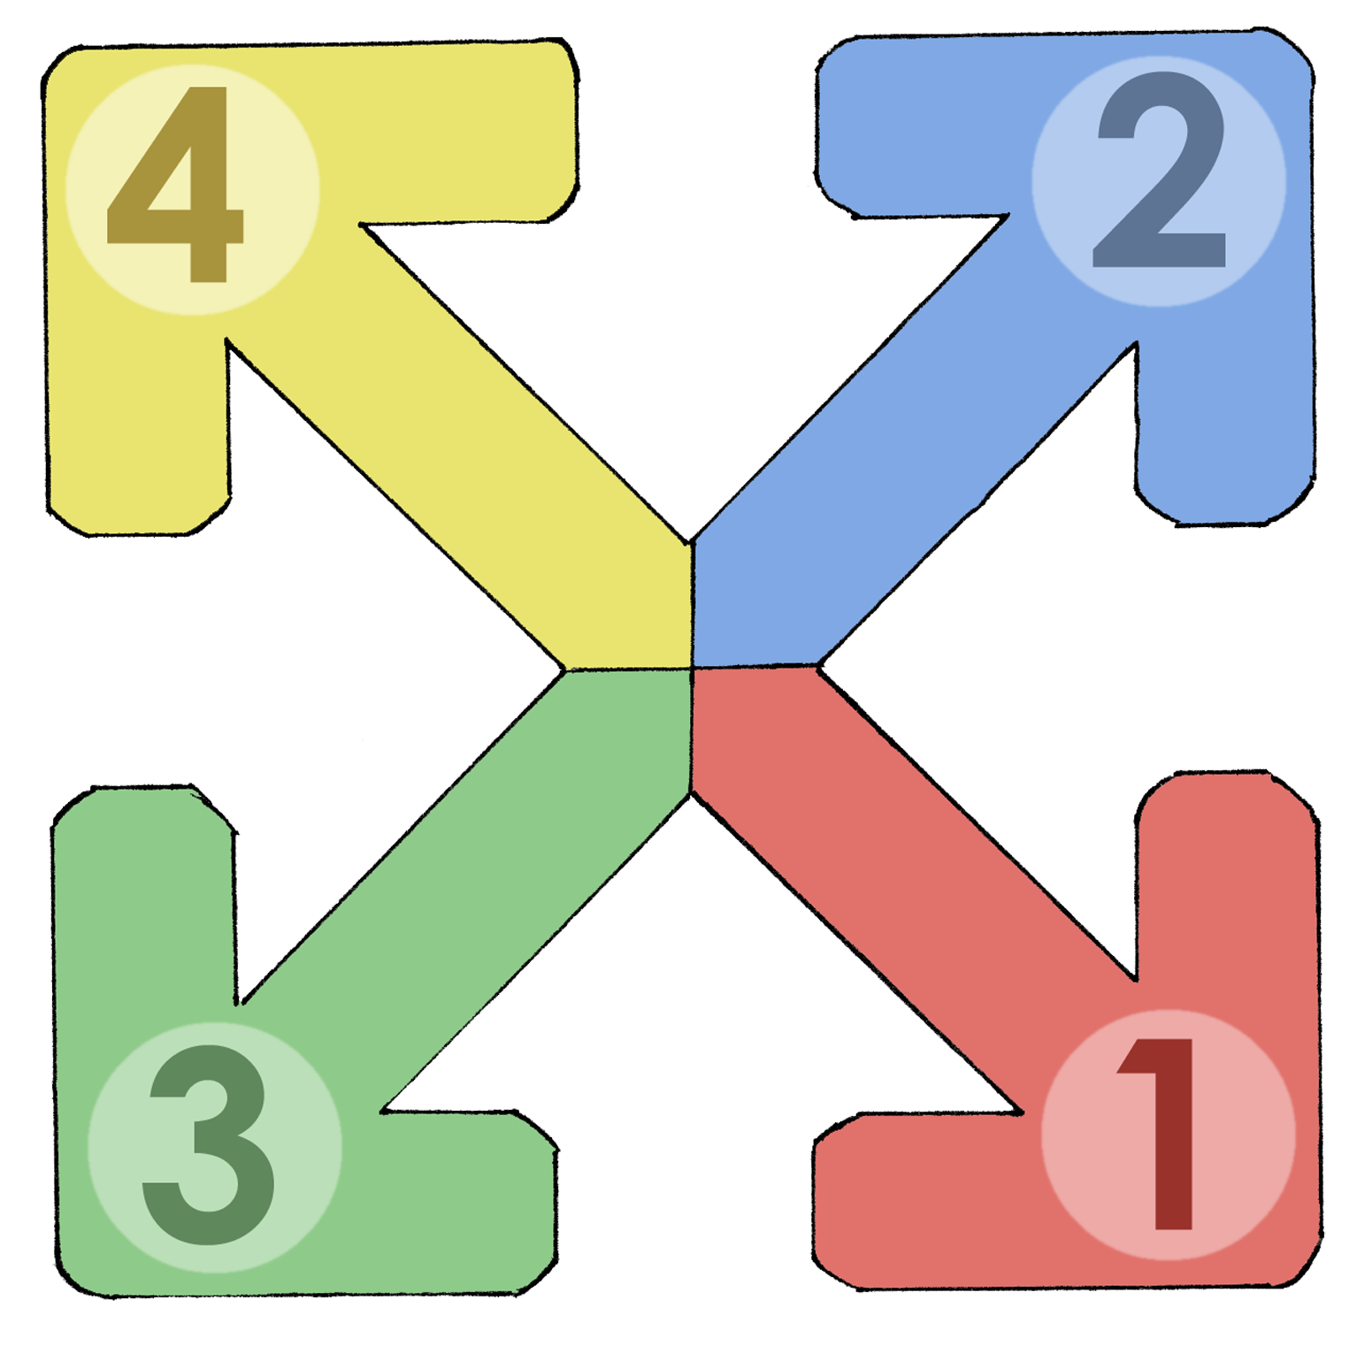

- Jede Ecke des Klassenzimmers wird betitelt:

- Lehmweg
- Gepflasterte Straße
- Autobahn
- Formel-1-Ring

- Die Schülerinnen und Schüler begeben sich in jene Ecke, die ihr Vorwissen und ihre Erfahrungen (oder ihr Können) zum neuen Thema am besten trifft.

- Anschließend tauschen sie sich in der Gruppe zum Thema aus. Sie erzählen, sammeln, diskutieren usw.

- Die vier Gruppen bekommen (differenzierte) Arbeitsaufträge.

JIGSAW TECHNIQUE
Kopiervorlage FG 2A
Students’ Task Sheet
Overall Topic: _____________________________
Text 1: ___________________________________
Text 2: ___________________________________
Text 3: ___________________________________
Text 4: ___________________________________
Instructions:
Step 1:
Today you are going to work on four different texts in four groups.
Each of you will be given a text on an aspect of a (certain) topic.
Step 2:
IW (Individual work): Read the text thoroughly and make notes on the most important aspects. You will have to sum up the text for classmates who do not know it.
Step 3:
GW (group work): Find three people in class who worked on the same text (= home group).
Exchange information, discuss the text and ask each other questions so that you make sure you have understood the information in the text.
Step 4:
GW: Find people in class who worked on the three other texts and form the expert group.
In your group of four, inform the others about your own text and collect information on the other texts. Again, ask questions and take notes.
Step 5:
GW: Get together with the students from your first group (= home group).
In your home group you prepare 10 questions on your text and create a game or a quiz, e.g., a Kahoot.
Step 6:
Prepare to play the game/quiz with your peers.
Consider if you want to award a prize for the winners.
Mind that you will only be allowed to participate in the games created by the other groups than yours.
Kopiervorlage FG 2B

JIGSAW TECHNIQUE
Explanation
INDIVIDUAL WORK | STAMMGRUPPE  = HOME GROUP | EXPERTENGRUPPE  = EXPERT GROUP | STAMMGRUPPE  = HOME GROUP
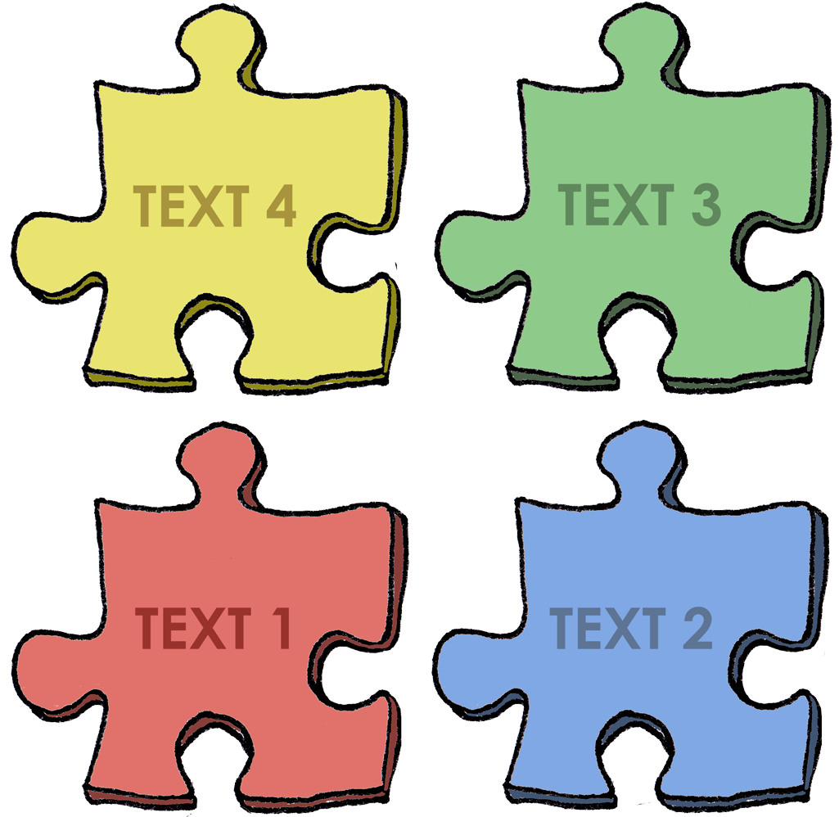  Text 4  Text 3  Text 2  Text 1  Text 4  Text 3  Text 2  Text 1  Text 4  Text 3  Text 2  Text 1  Text 4  Text 3  Text 2  Text 1 | 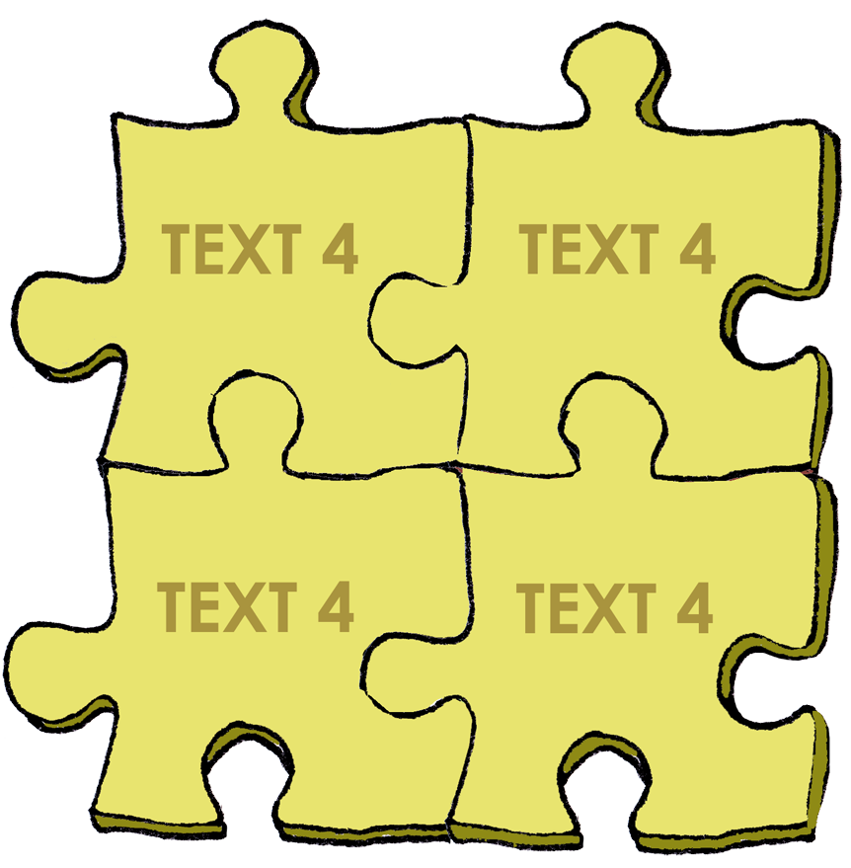 | 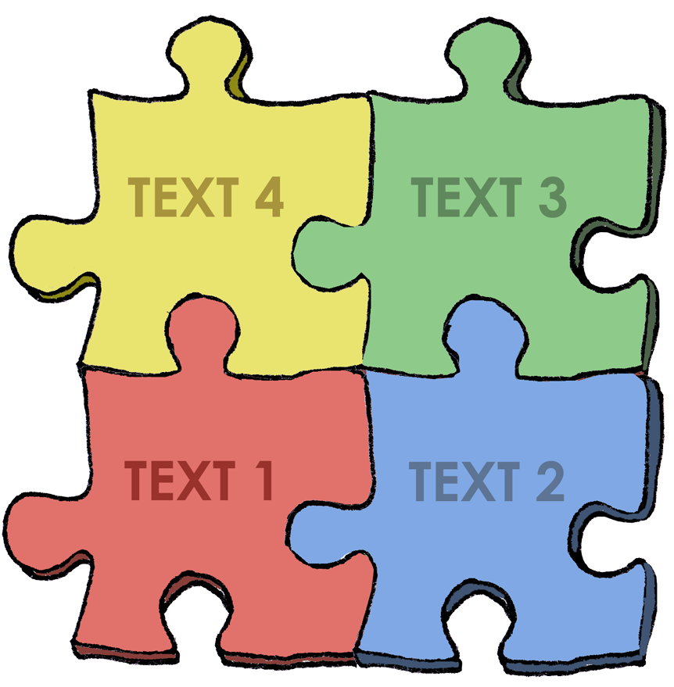
 | 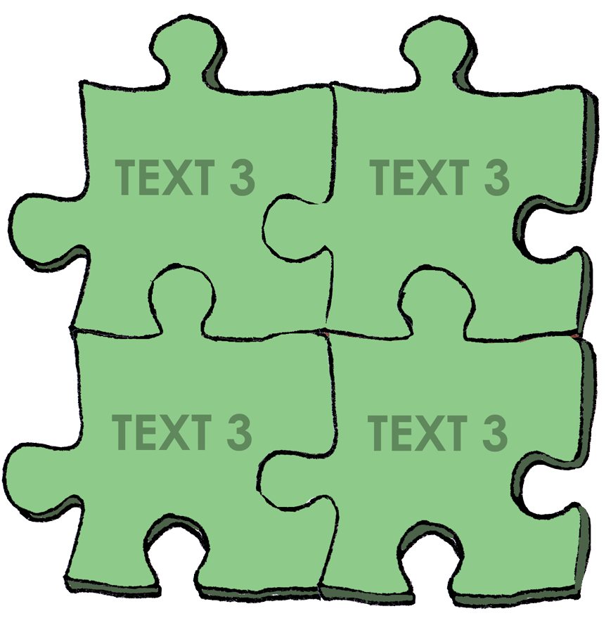
 | 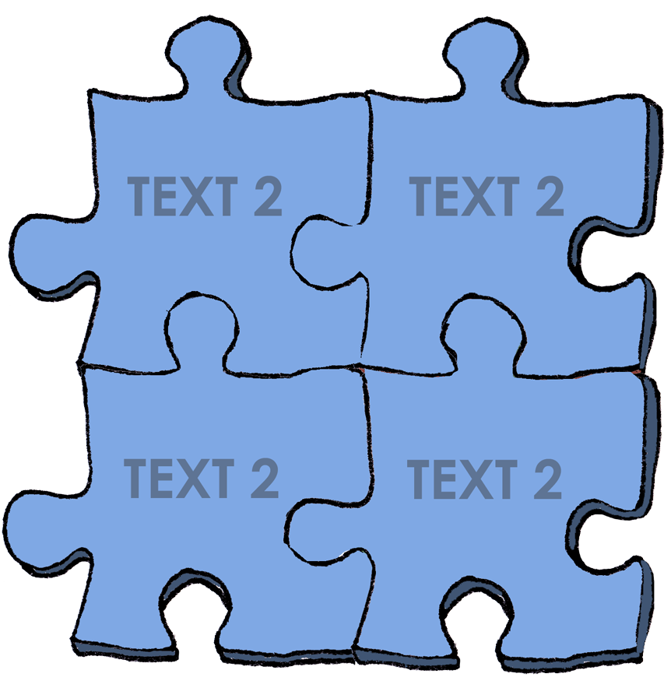
 | 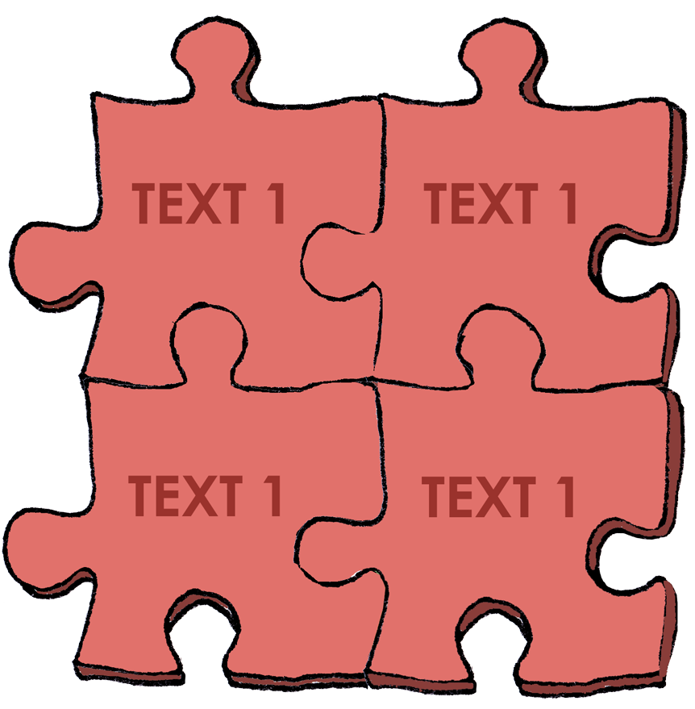

- Englische Lerninseln – Handouts

Kopiervorlage EL 1

Beispiel: Lerninsel für 4. Klasse Volksschule
Lernmaterial | Kurzbeschreibung | Taxonomie-stufe Bloom | main skill
Interaktive Landkarte „My World“ (2019, Best Learning) | Das Material bietet ein authentisches Sprachangebot, die Quizfunktion entspricht dem kindlichen Lernen. (Das eher etwas lautere Material funktioniert leider nicht mit Kopfhörern.) | 4 | listening
Story Cards (z.B. von www.twinkl.at/resource/tell-me-a-story-cards-za-hl-191) | Die Karten dienen als Sprech- und Erzählanlass auf der Satz- und Textebene. | 4 | speaking
App PuppetPals2 (2018, Polished Play LLC)  + Tablet und ggf. Kopfhörer | Schülerinnen und Schüler manipulieren Figuren, die Aufnahmefunktion ermöglicht die Aufnahme von gesprochenen Texten/Dialogen. | 3 | speaking
Tiptoi – Grundschulwörterbuch Englisch (2013, Ravensburger) + Tiptoi-Stift | Kindern vielfach bekannt, deshalb einfach einsetzbar. Mit Tiptoi-Stift bietet das Grundschulwörterbuch Lese- und Aussprachetraining zu grundschulrelevanten Themen, interaktive Vokabelspiele sowie die Aufnahme von Geräuschen und Sprache. | 2–3 | listening
Reihe „Playing Vocabulary“: „Town & Country” (LingoPlay) | Suchspiel (Vokabeltrainer, Konzentration): Wer das auf der eigenen Karte fehlende Motiv/Wort als erstes nennt, darf eine neue Karte vom Stapel nehmen. | 2 | speaking
Buch „My First Book of London“ (Guillan, C., 2018, Bloomsbury) | Das Buch ist selbsterklärend und die Illustrationen und Fotos sehr ansprechend. Ergänzend zum Text werden Fragen angeboten, welche den Lesenden als Grundlage zur Interaktion mit Mitschülerinnen und Mitschülern dienen können. | 2 | reading
Buch „Katie in Scotland“ (Mayhew, 2014, Orchard) | Landeskundlicher Inhalt in Verbindung mit „world of fantasy“: Nessie begleitet Katie, Jack and ihre Großmutter durch Schottland. | 2 | reading
Lernzeitschrift „Winston Express“ (No. 9, May 2021, ÖJRK & Buchclub, S. 3, 6 und 7) | Arbeitsblätter zu Europa und europäischen Hauptstädten | 2 | reading
Lernzeitschrift „Winston Express“ (No. 10, June 2021, ÖJRK & Buchclub, S. 6–8) + ein Würfel und zwei Spielfiguren | Arbeitsblatt zu „London/sightseeing“ | 2 | reading
Buch „My First Atlas“ (2022, HarperCollins) | Ergänzung zur interaktiven Landkarte „My World“, Informationen zum Nachlesen | 1–2 | reading

Kopiervorlage EL 2A

MÖGLICHE MATERIALIEN UND ÜBUNGEN FÜR LERNINSELN

ZUM SELBST ERSTELLEN
Elementary to advanced

Lernmaterial | Differenzierungsmöglichkeiten | Einsatzbereiche
1. Triminoes | 9 oder 24 Teile:  je nach Level der Lernenden  (siehe Kopiervorlage EL 2CDE) | - Past tense forms/irregular verbs  - Vocabulary: word-picture/definition  - Comparison of adjectives  - Telling the time
2. Dominoes | 12 oder 24 Teile:  entsprechend dem Level der Lernenden | - siehe Triminoes
3. Memory | 2, 3 oder 4 zusammengehörende Karten:  je nach Schwierigkeitsgrad | - siehe Triminoes und Dominoes
4. Taboo Games | Anzahl und Schwierigkeit der „Tabu-Wörter“ | - Vocabulary: definitions/explanations – zum Üben und Festigen (siehe Kopiervorlage EL 2B)
5. Board Games/Card Games | Selbst gezeichnete oder ausgedruckte Spielpläne mit Fragekarten in unterschiedlichen Schwierigkeitsstufen | - Diskussion von Inhalten eines Romans oder von Texten im Kursbuch
6. Vocabulary tasks | Anforderungsstufen:  - crossword  - Lückentext +/- word bank  - Wort → Definition  - Definition → Wort | - Übung von Vokabular  - Erstellung von Vokabelüberprüfungen (siehe auch Portfolio)
7. Questionnaires | Je nach lexikalisch-struktureller und/oder thematisch-inhaltlicher Zielsetzung | - Einüben und Transfer grammatikalischer Strukturen  - Abfrage/Erschließung von Inhalten
8. Online-Material:  Kahoot, Quizlet | Die Online-Angebote werden genutzt zur Erstellung eigener Lernsets und Quizzes | - Erstellung von Übungs- und Testmaterial für die Schülerinnen und Schüler

Kopiervorlage EL 2B

CREATE YOUR OWN TABOO GAME
Students’ Task Sheet

- Pick 10 – 15 words from the unit vocabulary and create taboo cards.

WATCH
TIME
CLOCK
WRIST
LOOK
- This is the basic idea:
- you pick a word – guess word – and
- choose 3-4 taboo words that must not be used to explain the ‘guess word’

- There are several options to make your task more difficult:
- you may choose more than 3 – 4 ‘taboo’ words
- any of your own ideas are welcome

- You can signal the level of difficulty on your card (*/**/***)

- As soon as you are done, all your cards will be collected and you’re going to play the game to recap and train vocabulary.

- The group will be broken into two teams – Team A and Team B.
A round in the game takes one minute.
A timekeeper signals when the minute is up.

- The first player of Team A takes the first card and as quickly as possible – gives clues (explanations only) for the ‘guess word’ on the card to their teammates; they shout out answers, trying to guess the word. Each time your team guesses a word correctly, your team scores a point. Keep playing until the minute is up.

- Now it’s Team B’s turn to go on.

Kopiervorlage EL 2C

TRIMINO – IRREGULAR VERBS
(Basic – 9 pieces)

- Match the present forms with the past forms.
- Put the pieces together so that they form a big triangle Δ.
- Then check with the key.

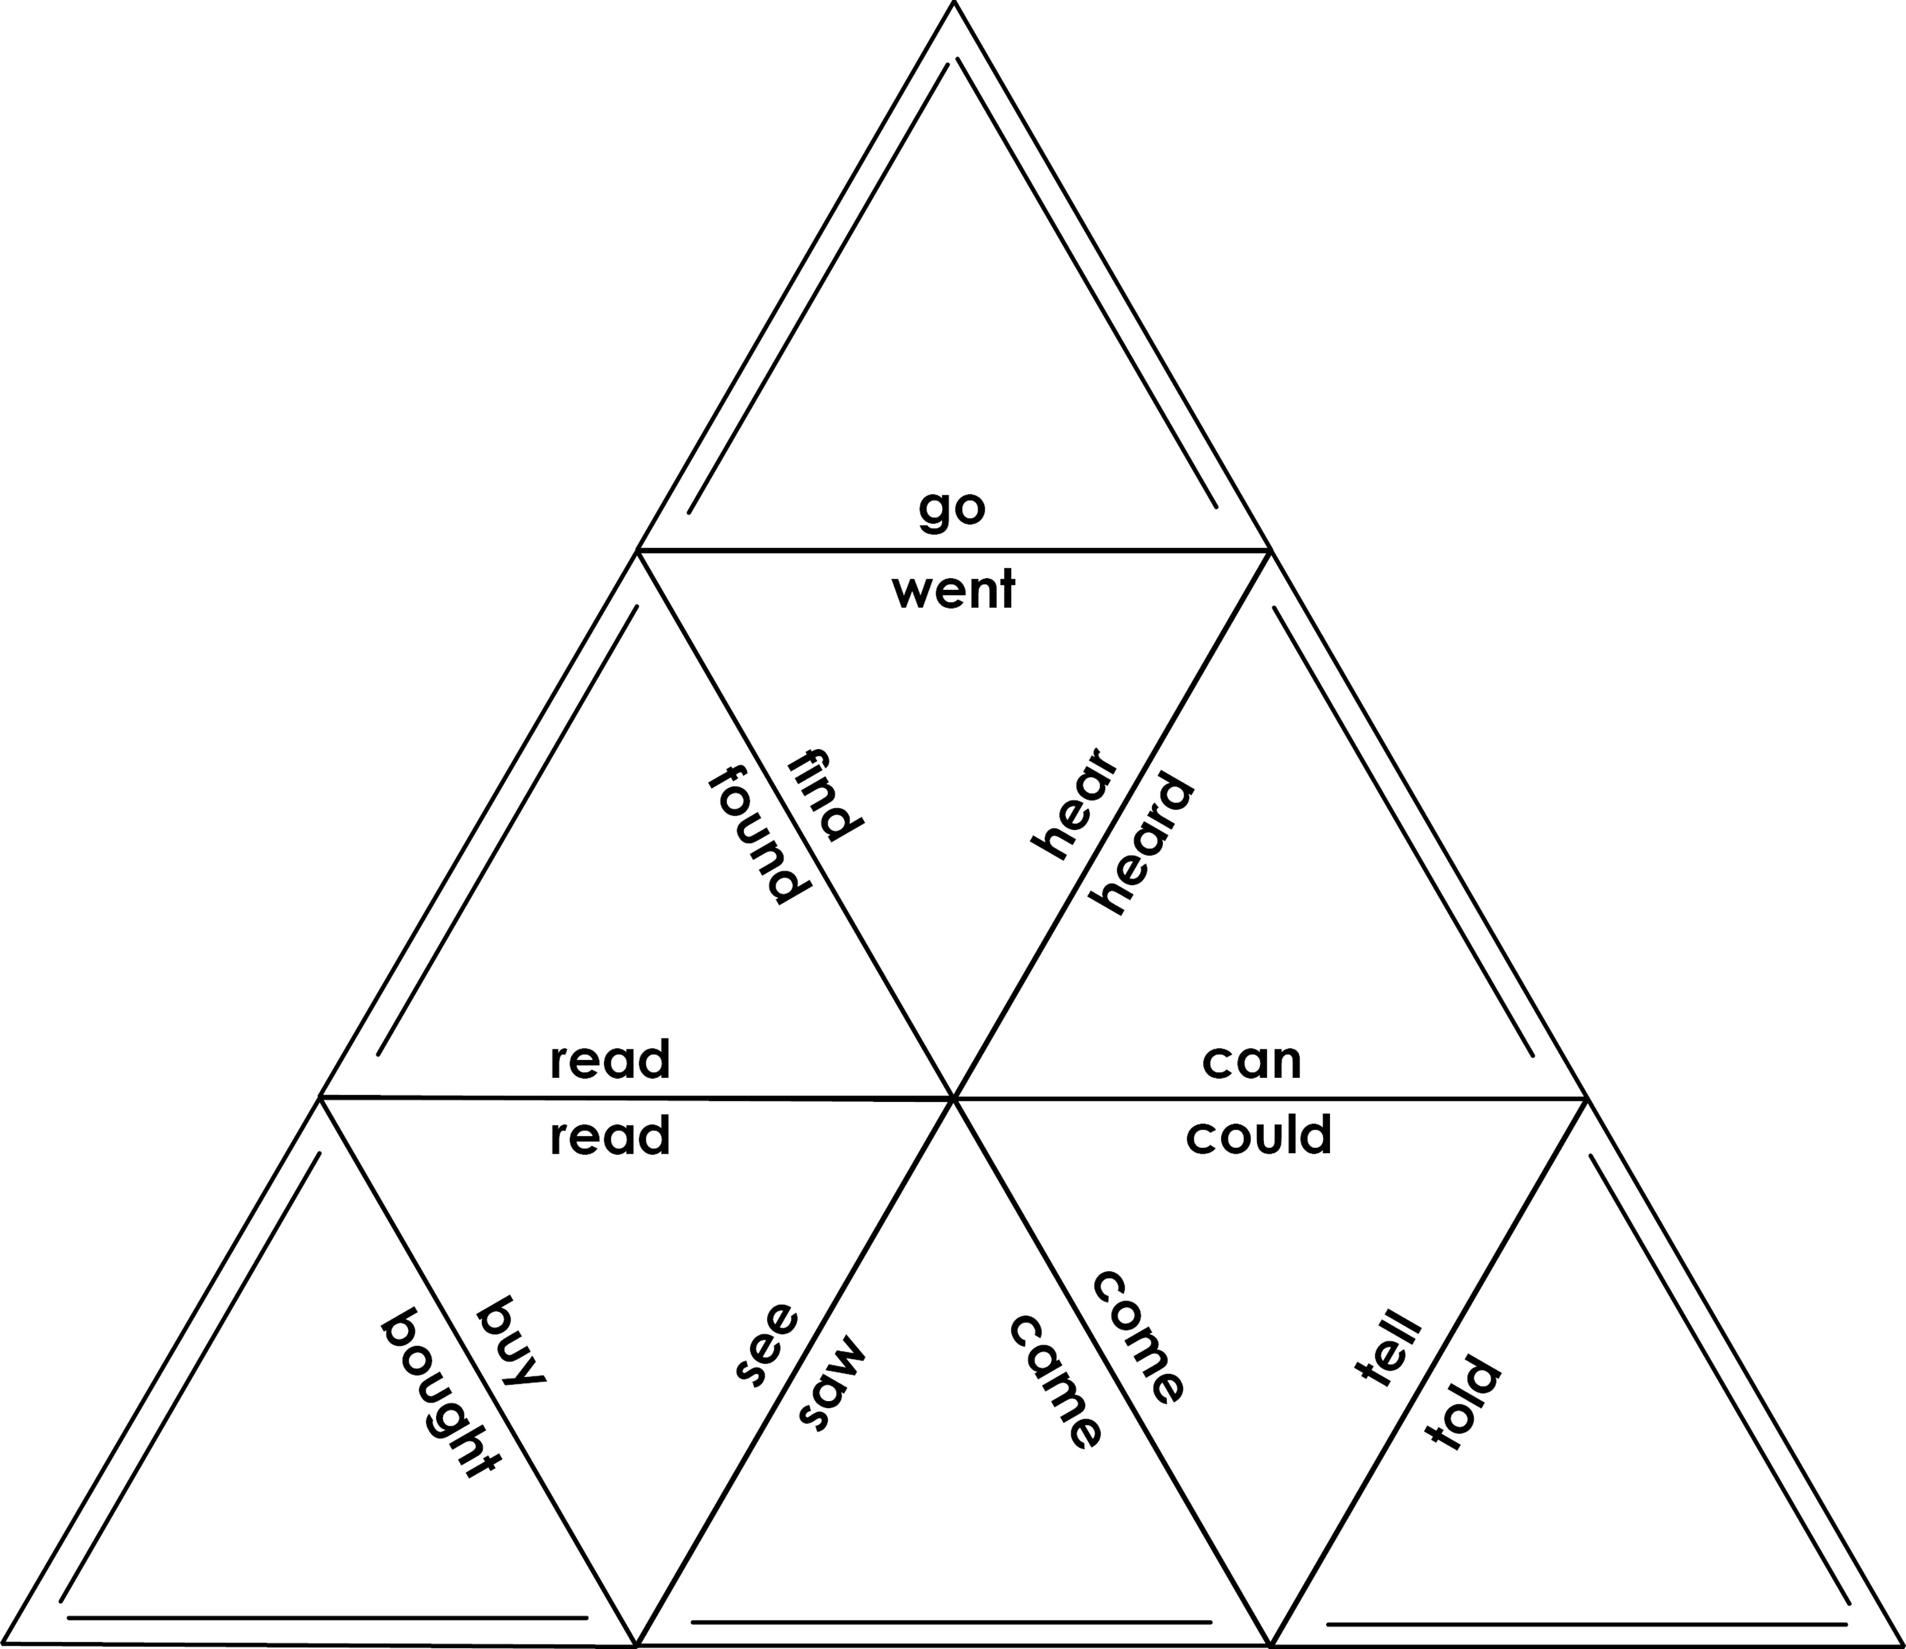

Kopiervorlage EL 2D

TRIMINO – IRREGULAR VERBS
(Advanced – 24 pieces)

- Match the present forms with the past forms.
- Put the pieces together so that they form a big hexagon.
- Then check with the key.
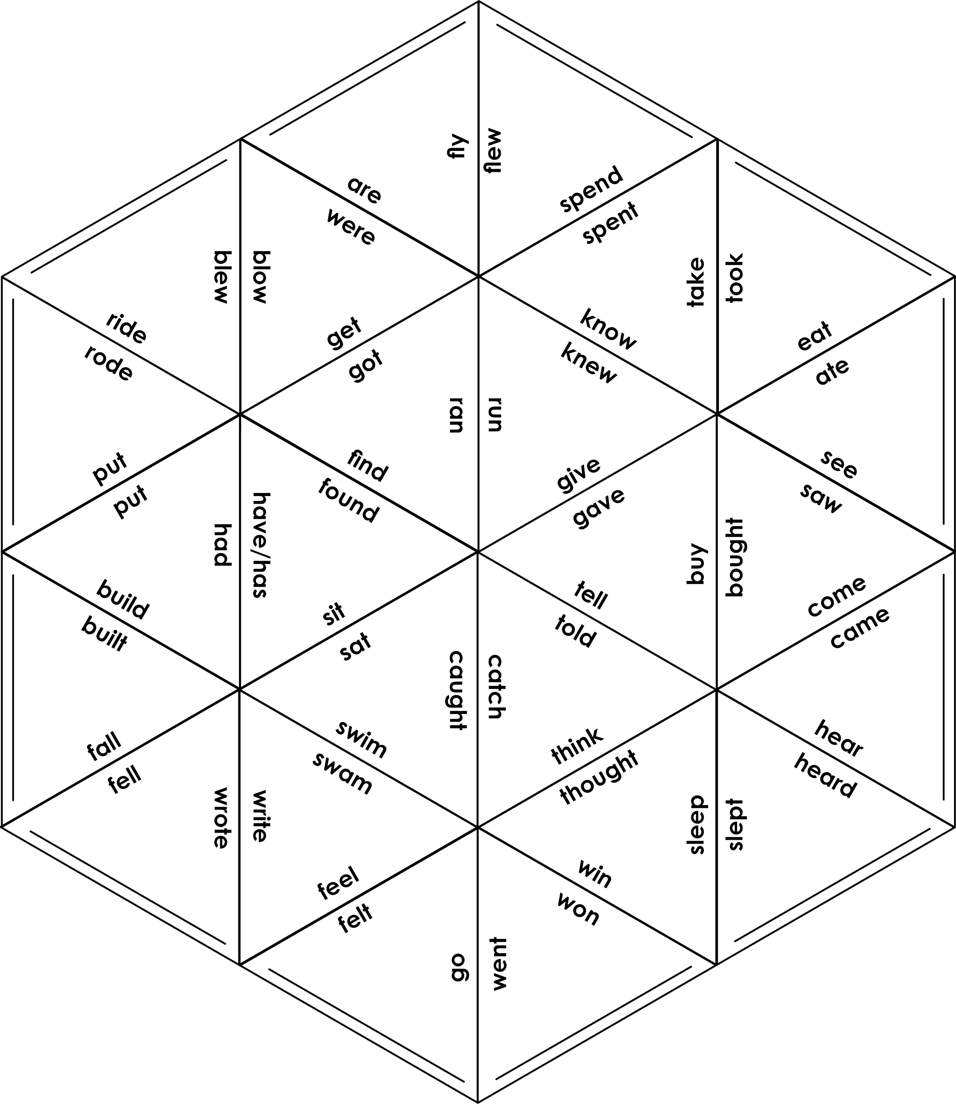

Kopiervorlage EL 2D

CREATE YOUR OWN TRIMINO
(24 pieces)

- Create your own trimino to practise irregular verbs.
- Cut out the pieces and give them to another student.
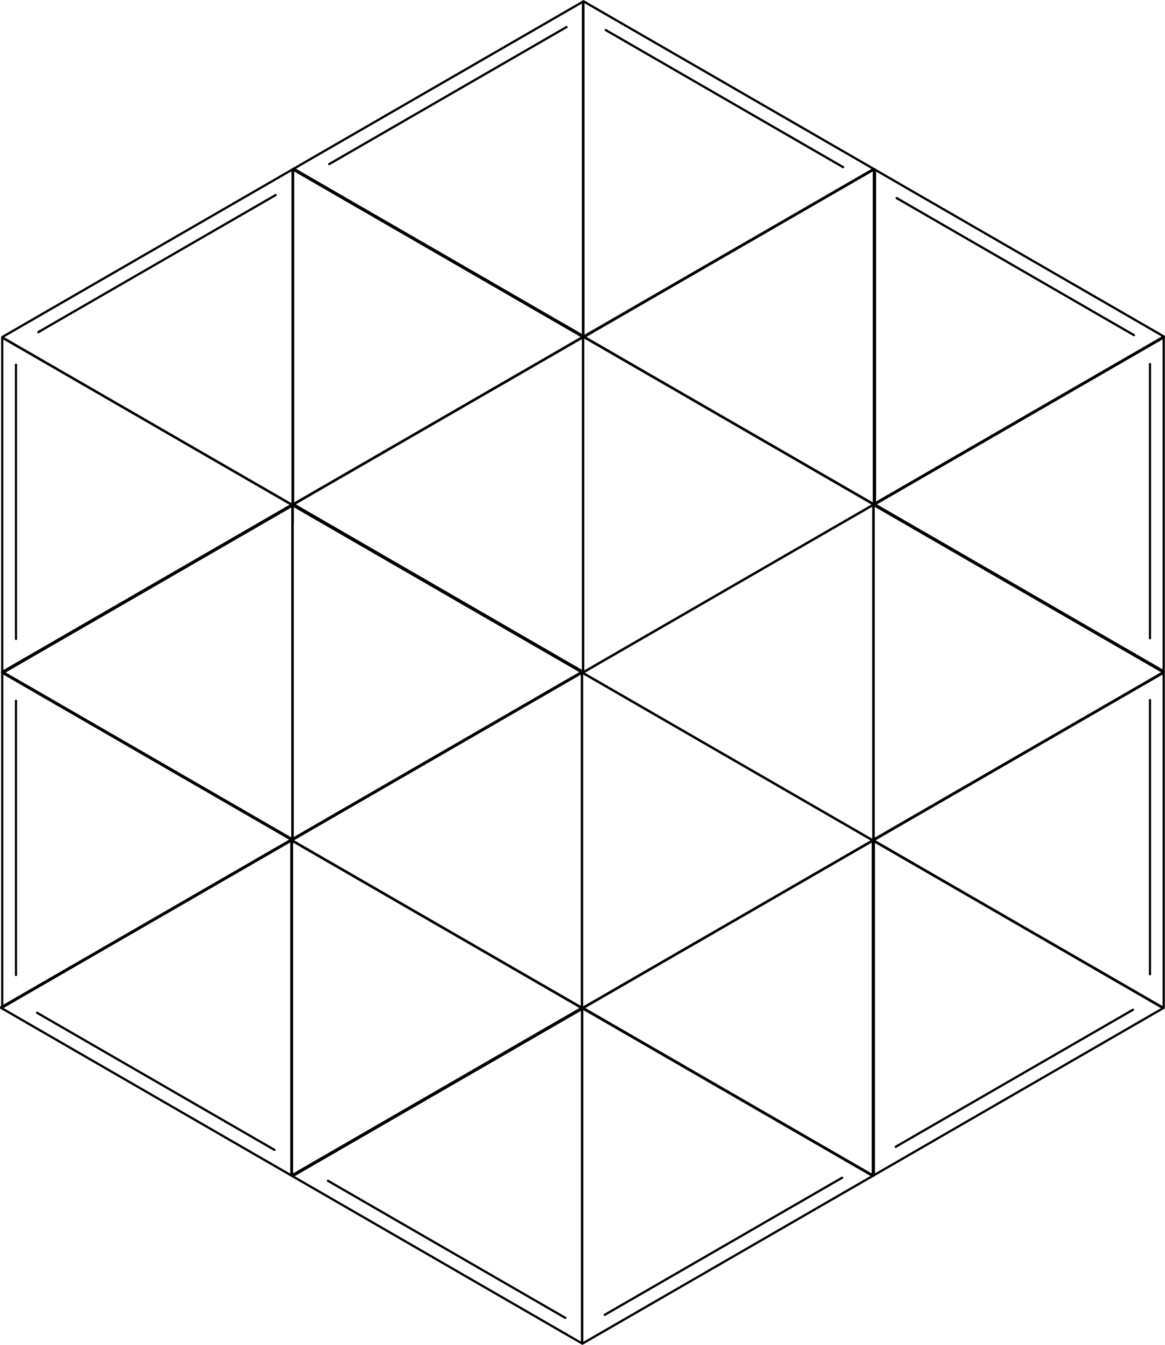
- Remember to prepare a solution sheet.

- Stationenlernen – Handouts

STATION PLAN
Kopiervorlage SL 1
Template

Name: __________________________ |  | Mandatory !  Optional + | Solo ☺/pair-☺☺ group work ☺☺☺ | Level of difficulty: */**/*** | Time □ | Material needed | Key/Self-correction | To be handed in | 
Station 1 | 1.1. Activity/Task:
 | 1.2. Activity/Task:
Station 2 | 2.1. Activity/Task:
 | 2.2. Activity/Task:
Station 3 | 3.1. Activity/Task:
 | 3.2. Activity/Task:
Station 4 | 4.1. Activity/Task:
 | 4.2. Activity/Task:
Station 5  Station 5 | 5.1. Activity/Task:
 | 5.2. Activity/Task:
Learning Objectives (LO) |  | ++ | + | □ | - | --
I can ... | ... [LO 1]
 | ... [LO 2]
 | ... [LO 3]
 | ... [LO 4]
 | ... [LO 5]

SELF-REFLECTION ON WORKING WITH LEARNING STATIONS
Kopiervorlage SL 2

- This is what I learned …

- This was easy for me …

- This was difficult for me …
- I still have a question on …
- I could/could not work well because …
- This is what I will do differently next time:
- I still need help with …

This could help me:

Kopiervorlage SL 3

FEEDBACK ON WORKING WITH LEARNING STATIONS

 | I completely agree | I somewhat agree | I am undecided | I somewhat disagree | I completely disagree
1. The tasks were clear to me. I knew what was expected. | 1 | 2 | 3 | 4 | 5
2. The tasks were relevant and helped me to improve. | 1 | 2 | 3 | 4 | 5
3. I felt encouraged to work well. | 1 | 2 | 3 | 4 | 5
4. The allotted time was okay. | 1 | 2 | 3 | 4 | 5
5. I would like to work with an assignment plan again. | 1 | 2 | 3 | 4 | 5
6. My suggestions to improve the assignment plan:

- Offene Aufgaben – Handouts

Kopiervorlage OA 1A

CREATE YOUR OWN ISLAND
Students’ Task Sheet

- Imagine the following situation/setting:
Real estate developers have hired you to create a new island.
Your island needs to have its own economy and infrastructure, its development should be environmentally friendly. You will also have to show the inhabitants how they will be able to make a living.

- Create your own island and present your results in a brochure: see requirements below

- Sources for inspiration:
  - Geography:
- Draw a map of your island
- Create a name for your island
- Design your own flag
- Define the location of your island: latitude (N or S) and longitude (E or W)
- Define names for the capital city and major towns and/or smaller villages
- Explore and explain the landscape (rivers, mountains, lakes) and vegetation (animals, plants)
- Describe the climate: temperatures, seasons
- Research countries that share the latitude/longitude.
- Identify the languages spoken on the island.

  - Economy:
- Design your own currency (= money) for the island.
- Identify the population:
- Has the island been populated?
- Who are the inhabitants? Number of inhabitants?
- What is their name? Will there be a new name?
- Classify the island’s natural resources (= things that are there naturally):
- How will the natural resources influence the inhabitants’ way of living and the economy?
- How will the islanders benefit from the natural resources?
- Explain how people can make a living on the island:
- What types of businesses will there be on your island?
- How will people be able to get food and water?
- What is special about your island? Who shall travel to the island? What does your island offer?
- Develop a plan for how your island is going to protect the environment.

p. 1

Kopiervorlage OA 1B
- Customs and Traditions:
- Invent a unique celebration held there on the 4th of January each year. Describe the celebration, e.g., explain why it is held and what happened when you took part in it once.
- Create the island legend: Make up a legend about this place and let this contain a song about the place or the story. Find a tune and the lyrics.
- Compose a particular dish/meal/delicacy that is prepared and eaten on the island: Create a recipe with the name of this delicacy, its preparation, taste and texture. Make the listeners imagine the delicacy in their minds – get their “taste buds“ working!
- Invent a story about a mythical beast (long since thought extinct – or considered as a “beast of the imagination“) that lives in this place: Write about what happened when you first encountered this mythical beast and how you escaped to tell the tale!
  - Lifestyle:
- Imagine you have spent a week on the island and are now going to write a review for a social media platform (e.g., Facebook, Instagram, Snapchat) in which you explain why you liked (did not like) your holiday there; include a ranking.
- Interview: Imagine you’re spending a week on the island and meet one of the island celebrities. Produce a podcast (audio or video) in which you interview the person about why they live on the island, what they do for the island, etc.
- Insta-Story: As a holiday maker on the island you’re going to share your impressions with your friends at home. Create an Insta-Story showing the best pictures of the island with a short text to follow.

- Project requirements:
  - Brochure:
- Design a cover page
- Cover the fields “Geography”, “Economy”, “Customs and Traditions” as well as “Lifestyle” in your individual and creative way
- Illustrate your brochure with attractive pictures
- If you type your brochure use at least 11pt (Calibri) and 1 ½ space in between lines
- Attach the Check list/Self-evaluation
  - Presentation: Prepare your presentation in the following way:
- Pick the three most appealing aspects of your island to talk about
- Use some visual material, e.g., pictures, coins, etc. to illustrate your message
- Write the key information on cards (as explained in class)
- Prepare well and rehearse your presentation so that …
- … you speak fluently (NO READING from your cards!!)
  - Brochure to be handed in: ___________________ (date)
  - Presentation to be held: ___________________ (date)
p. 2
Kopiervorlage OA 2

CREATE YOUR OWN ISLAND
Check list – Self-evaluation

This check list must be handed in with your project brochure by _______________________
There will be a point taken away for every day that you hand your project in late.

Requirement | Score
My brochure contains all the documents. |  |  | 2
My island includes important geographical features. | 4 | 3 | 2 | 1 | 0
My project covers key information on “Economy“. | 4 | 3 | 2 | 1 | 0
In the “Customs and Traditions“ section I worked out at least two of the tasks. | 4 | 3 | 2 | 1 | 0
I carried out the “Lifestyle“ features. | 4 | 3 | 2 | 1 | 0
I followed instructions to prepare my presentation. | 4 | 3 | 2 | 1 | 0
I illustrated my brochure/project with attractive visual material. |  | 3 | 2 | 1 | 0
I effectively used class time to complete my project. |  | 3 | 2 | 1 | 0
I included the check list. |  |  | 2

TOTAL: _________ / 3O points

Explain the scores in your Self-evaluation:
___________________________________________________________________________
___________________________________________________________________________
___________________________________________________________________________
___________________________________________________________________________
Kopiervorlage OA 3

PREPARING FOR A DISCUSSION
ON
________________________________________

- Which questions first pop up in your mind when you hear the topic/problem?
- What are your own experiences with the topic? Have you already been confronted with the issue in your life?
- In your opinion, which aspects must definitely be mentioned in the discussion?
- Which aspects do you find worthwhile to investigate more?
- If you view the problem from a different perspective, what is it like then?
- What could be positive or negative consequences?
- Which future measures would solve the problem?
- What would happen if the problem disappeared as such?

- Forschendes Lernen – Handouts

THESIS PAPER: IS IT RIGHT TO EAT MEAT?
Kopiervorlage FL 1
Students’ Task Sheet
Instruction
- Read the ten statements.
- Cross out seven statements you don’t like/you think are wrong/not interesting and choose three statements you like/you find interesting/you think are worth discussing.
- Group work: Get together in a group with two students with a similar choice. In the group, discuss the statements.
- Which statements do you have in common?
- Why did the others choose a statement you discarded?
- Discuss the statements and exchange opinions, experiences, examples.
- Individual work: Choose one of your three statements and do some research online.
(Start doing the research at school and finish at home.)
- Look for arguments for and against it.
- Find expert opinions.
- Try to find studies/surveys/statistics that confirm or refute the statement.
- Sum up your findings.
Meat consumption destroys  our environment. | Eating meat causes  unnecessary animal suffering.
Slaughtering animals  is morally wrong. | Humans have always  been meat eaters.
Eating meat is a pleasure  as meat tastes good. | Animals also  eat animals.
Humans need meat as a source  of protein, vitamins and minerals. | Eating meat is speciesism  (= discrimination based on species membership).
High meat consumption  is unhealthy. | Animals are bred  to be eaten.
- Express your own opinion.
Present your findings in class. React to other students’ arguments.

- Begabungsfördernde Leistungsbeurteilung – Handouts

SELF-ASSESSMENT
Kopiervorlage BFL 1A
Elementary to intermediate

Criteria | Weighting | + + | + | □ | - | - -
I contribute to class by giving answers, offering ideas or asking questions several times each class.
My comments are relevant.
I am willing to study vocabulary and use it.
I pay attention and listen to my classmates and my teacher.
I actively work in pairs and groups.
I finish assignments as well as possible.
I take notes without being asked to do so.
I always do my homework (including the upload of audios and videos) on time.
I am prepared for class and have all my books and material with me.
I hardly ever chat or show negative behaviour.

My explanation for the grade that I deserve for participation:
________________________________________________________________________________________________________________________________________________________________________________________________________________________________________________________________________________________________________________________________________________________________________________________________________________________

SELF-ASSESSMENT
Kopiervorlage BFL 1B
Intermediate to advanced

Criteria | Weighting | + + | + | □ | - | - -
I contribute to class by volunteering answers, sharing ideas or asking questions several times each class.
My contributions are relevant.
I am willing to enlarge my lexical range and use it actively in discussions and texts.
I pay attention and listen to my classmates and my teacher.
I actively contribute to pair and group work.
I finish assignments as well as possible.
I take notes without being prompted.
I do my homework regularly and in time (including requested uploads of audios and videos).
I am prepared for class and have all my books and material with me.
I hardly ever chat or show inappropriate behaviour.

My explanation for the grade that I deserve for participation:
________________________________________________________________________________________________________________________________________________________________________________________________________________________________________________________________________________________________________________________________________________________________________________________________________________________

- Formatives Assessment – Handouts

Kopiervorlage FA 1

1A

Evaluation Landscape
Instructions

Today we’re going to work with a so-called “Evaluation Landscape”: Based on objects/items in a landscape you shall find out how you see your learning success/progress in English.
- First we’ll label all objects and places in this picture.
- Mark the spot in the landscape that shows how/where you see your learning success in English at this moment.
- Let’s now find sentences to express your ideas in English.
- Then write down where you see yourself and why this spot/object stands for your success.
- Think about your future:
- Where would you like to be by the end of the year/in one year’s time?
- What could you do to get there?
- When you are finished, I’d like to talk with you about your current situation and your future perspective.

Kopiervorlage FA 2A

1A

Feedback on Methods in the English Classroom
Teachers’ Checklist

- Suggestions for methods and activities to be included:
Beginners to intermediate:
- Presentations/Explanations by the teacher
- Presentations/Explanations by peers
- Self-study projects and activities
- Pair work/group work
- Additional practice material
- Coursebook/workbook tasks
- Self-generated study material
- Reading English books
- Recording speaking tasks
- Group feedback
- Individual feedback
Additional activities to be considered for intermediate to advanced:
- Various types of discussions: fishbowl, talk show, debate, press conference
- Video sources (e.g., TED talks, news) as basis for Flipping the classroom
- Recordings of individual/group productions: film sequences, news, press conference
- Self-management/personal mastery: time management, teamwork, perseverance

- Subdivision of the circle into segments and labelling of the sections:
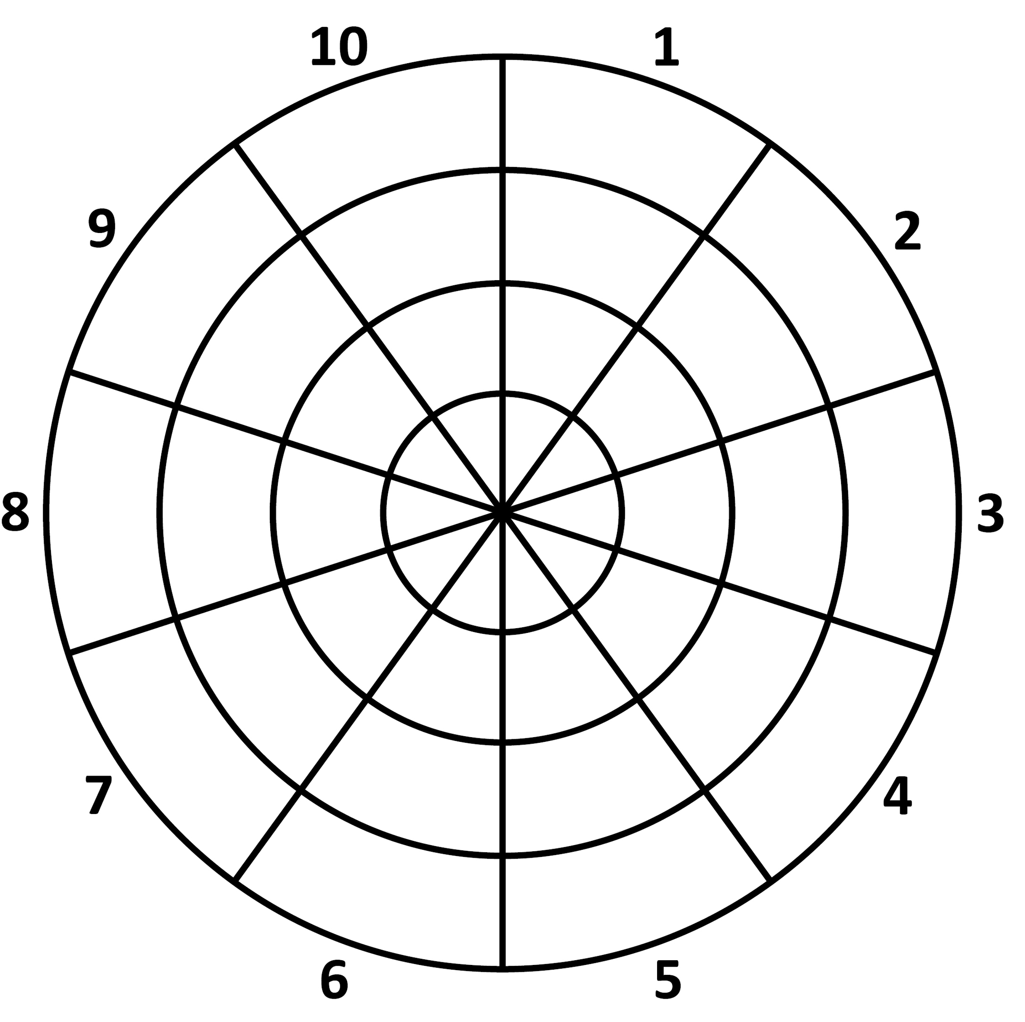
1.
2.
3.
4.
5.
6.
7.
8.
9.
10.

Feedback on Methods in the English Classroom
Kopiervorlage FA 2B

1A
Students’ Task Sheet
How do the methods and activities in class support your progress in English?
- The segments of the circle show activities and methods in our English classes.
- Put a dot into each segment.
- The closer the dot is to the centre the more the method is helpful for you.
- The further away your dot is from the centre the less the method helps you.
- Explain the position of your dots in the spaces provided below.
- Presentations/Explanations by the teacher
- Presentations/Explanations by peers
- Self-study projects including own presentations
- Pair work/Group work
- Self-generated study material
- Addional practice material
- Reading English books
- Recording speaking tasks
- Group feedback
- Individual feedback

Explanation/Justification:
1. |  | 6.
2. |  | 7.
3. |  | 8.
4. |  | 9.
5. |  | 10

For general feedback on our class work please answer these questions:
1. Are there aspects where you would like to work more in detail?
 Yes, which ones: __________________________________  No
2. Are there any interests or skills that should be covered in our class work?
 Yes, which ones: __________________________________  No
3. Are there any additional methods that may help you?
 Yes, which ones: __________________________________  No

- Förderorientierte Leistungsrückmeldung durch Peer-Feedback – Handouts

Kopiervorlage FLR 1A

WRITING TASK
Recommendation of a film/series

An online movie platform for teenagers asks their members to discuss their favourite film or series. You decide to post your recommendation of a film/series.

In your text you should …
provide basic information about the film or series (title, genre, director, production date),
describe the main story and main characters,
give reasons why someone should watch exactly this film/series.

Write about 200 words.

REMEMBER:
Five paragraphs: introduction – bullet point 1 – bullet point 2 – bullet point 3 – conclusion
Leave a blank line between paragraphs.
Use linking devices.

IMPORTANT:
Avoid “copy and paste” from the Internet – it immediately shows in your text!

Kopiervorlage FLR 1B

PEER FEEDBACK with sticky notes
Students’ Task Sheet

Instructions:

- Take five sticky notes and read five of the texts spread out on the wall/desks.
- On each sticky note, write down one positive comment and one constructive comment.
- Stick the notes to the five different texts on the wall/desks that you have read.

Useful phrases
Positive comments | This was good:  - It is a good idea to …  - What I especially like about your text/passage is …  - One strength of your text is …  - I really like the way you …  - … impresses me very much.  - It is interesting how you …
Constructive comments | This is what can be better next time:  - Next time you could …  - To improve your text you need to …  - One thing that needs to be added/left out is …  - One thing I would add/leave out is …  - A good idea would be to …

Kopiervorlage FLR 2

How to give feedback on texts
Students’ Task Sheet

Instructions:

- Read your peer’s text and give feedback using two pens of different colours (positive comments/constructive comments). You can also use sticky notes that you attach to the different parts of the text.

Use the ideas below for your feedback:

Criteria to focus on
Positive comments | - Tell the writer what you liked best about the ideas in the text. Talk about certain sentences, paragraphs, vocabulary you find striking.  - Note where there are cohesive/linked ideas, where the argument is clear/easy to follow and convincing, where the writer uses effective reasoning, and which ideas are well-developed.  - Record where a section was particularly attention-grabbing or intriguing, where the writer had a strong conclusion, and whether topic sentences were well-supported, and transitions were clear and effective.
Constructive comments, suggested improvements | - Note down whether or not the writer fulfils the task and the conventions of the text type.  - Point out if the analysis of the data is well-developed.  - Highlight passages/ideas that are unclear and need further development.  - Refer to the range of vocabulary and structure used in the text.  - Highlight parts where conclusions do not flow from the support provided.  - Examine the effectiveness of the conclusion.

Kopiervorlage FLR 3

FEEDBACK GRID FOR TEXTS
Students’ Sheet

Your introduction is stimulating.
You made good paragraphs.
You used linking devices.
Your conclusion is interesting/gripping.
Your storyline is easy to follow.
The vocabulary is striking.
You used a wide range of structure.
…
…

GIVING AND RECEIVING PEER FEEDBACK
Kopiervorlage FLR 4
Assessment Sheet

Giving peer feedback
How did you feel when looking for a positive aspect/a strength of a peer’s text?
___________________________________________________________________________
How did you feel when looking for a negative aspect/a weakness of a peer’s text?
___________________________________________________________________________
Was it difficult for you to give feedback on a peer’s text?
□ Yes □ No because _______________________________________________________
Was it helpful for you to read through other students‘ texts?
□ Yes □ No because _______________________________________________________
Receiving peer feedback
Was the feedback you received from your peers valuable?
□ Yes □ No because _______________________________________________________
In your opinion, could you optimize your text because of the feedback you received?
□ Yes □ No because _______________________________________________________
Overall
Do you agree that also students (and not just the teacher) can give valuable feedback on texts?
□ Yes □ No because _______________________________________________________
Did you like this activity?
□ Yes □ No because _______________________________________________________
Final remarks
___________________________________________________________________________
___________________________________________________________________________
___________________________________________________________________________
___________________________________________________________________________
___________________________________________________________________________

